THIRUMALAI ENGINEERING COLLEGE

KILAMBI, KANCHIPURAM-631551

DEPARTMENT OF COMPUTER SCIENCE AND ENGINEERING



CASE TOOLS LAB
(CS 6513)

NAME : _________________________________
REG. NUMBER : _________________________________
SEMESTER : _________________________________
YEAR : ___________________________________

LIST OF EXPERIMENTS

S.  NO. | DATE | NAME OF THE EXPERIMENT | PAGE NO | SIGN
1. |  | PASSPORT AUTOMATION SYSTEM
2. |  | BOOK BANK REGISTRATION SYSTEM
3. |  | EXAM REGISTRATION SYSTEM
4. |  | STOCK MAINTAINENCE SYSTEM
5. |  | ONLINE COURSE RESERVATION SYSTEM
6. |  | E-TICKETING
7. |  | CREDIT CARD PROCESSING
8. |  | SOFTWARE PERSONNEL MANAGEMENT SYSTEM
9. |  | E-BOOK MANAGEMENT SYSTEM
10. |  | RECRUITMENT SYSTEM
11. |  | CONFERENCE MANAGEMENT SYSTEM
12. |  | FOREIGN TRADING SYSTEM
13. |  | BPO MANAGEMENT SYSTEM
EX.NO:
INTRODUCTION ABOUT OOAD
DATE:

Objects have been used as the informal basis for the conceptual design of interactive systems for at least a decade. Given recent advances in the development of object-oriented modeling languages and methodologies, it is now timely to re-evaluate the role of object modeling during the process of user interface design.

OO MODELING AND USER INTERFACE DESIGN
User interface design techniques which incorporate object-oriented modeling techniques, e.g. to depict the domain, core objects, and interactive capabilities of an application have significant advantages, including the following:
- Object models act as a reference to the current state of a system design, and serve as a means of communication between user interface designers and system analysts and designers.
- Object models act as a focus for the user interface design process, providing a framework in which to view user tasks and the interactive capabilities of a putative system.
- Object models of interactive systems enable the specification of tasks and/or user actions. These specifications, which may be either formal or informal, are written in terms of state changes in an object model of an interactive system.
- The rigorous approach offered by the combination of object modeling and user interface design form a solid foundation for subsequent implementation efforts.
Looking to the future, it is likely that object-oriented modeling will become a standard part of the system life cycle. Consequently, it is of fundamental importance that the user interface design community provides methodologies that work in conjunction with object-oriented system analysis and design methodologies.

GOALS
The goals of the workshop are to bring together user interface design practitioners and methodologists in order to:
- Survey current practice and theory in object-oriented user interface design.
- Formulate an integrated approach to object modeling within the user interface design life cycle.

ISSUES
Dominant issues which the workshop will address in position papers and in small group discussions are:
- The role of object-oriented modeling techniques within user interface design methodologies
- A general framework for the integration of object-oriented and user interface design methods.
- Relating user interface design artifacts to object models.
- Notations for object-oriented user interface design.
- Description of users' interaction through use cases.
- The effects of interaction style on the structure of object models.
- Abstract object-oriented architectures and patterns for interactive system specification.
- Appropriate levels of formality during the design process.
- Systematic techniques for the revelation of domain objects and states at the user interface.
- Tool support for object-oriented user interface design.

OBJECT INTEROPERABILITY

Interoperability can be defined as the ability of two or more entities to communicate and cooperate despite differences in the implementation language, the execution environment or the model abstraction. Basically, three main levels of interoperability between objects can be distinguished: the syntactic level (names and signatures of operations), the protocol level (partial ordering between exchanged messages and blocking conditions), and the semantic level ("meaning" of operations).

Syntactic interoperability is currently well defined and understood at the interface level. The basic problem is that the study of interoperability at the other two levels currently presents serious challenges, from both the theoretical and practical points of view. This workshop focuses mainly on object interoperability at the protocol and semantic levels.

Interoperability is one of the key aspects related to the construction of large object-oriented systems, and it can be defined as the ability of two or more entities to communicate and cooperate despite differences in the implementation language, the execution environment or the model abstraction. Basically, three main levels of interoperability between objects can be distinguished: the syntactic level (names and signatures of operations), the protocol level (partial ordering between exchanged messages and blocking conditions), and the semantic level ("meaning" of operations).

Syntactic interoperability is currently well-defined and understood at the interface level, where now open systems architects and vendors are trying to establish different interoperational standards (CORBA, JavaBeans, COM, ...).

However, it is also recognised by all software developers that this sort of interoperability is not sufficient for ensuring the correct development of object oriented applications, should they be object-based or component-based applications.

But on the other hand, the study and usage of the latter two levels currently present serious challenges, from both the theoretical and practical points of view. There have been some partial advances in those levels, but we are still far from reaching any satisfactory solution. Object interoperability can embrace aspects besides and beyond components. Although often confused, components and objects can be really seen as orthogonal concepts, each one having its own specific and distinguishing features. In general, component interoperability can be seen as a particular case of the object interoperability problem.
Another interesting issue and closely related to object interoperability is replaceability, i.e. the polymorphic substitutability of objects in clients, or how to guarantee that the behavior of subclass instances is consistent with that of superclass instances. Interoperability and replaceability are the two flip sides of the object compatibility coin.
This workshop aims to promote research concerned with all aspects of interoperability and replaceability between objects, in particular at the protocol and semantics levels. Topics of interest include, but are not limited to:
- Enabling models, technologies and architectures for object interoperability.
- Interface and protocol matching.
- Mediated architectures and automated construction of mediators.
- Resource discovery based on semantic matching.
- Extensions to object interfaces and IDLs to deal with protocol or semantic interoperability.
- Formal aspects of interoperability.
- Object replacement and correct sub classing.
- Using coordination to achieve interoperability.
The workshop tries to provide a venue where researchers and practitioners on these topics can meet, disseminate and exchange ideas and problems, identify some of the key issues related to object interoperability, and explore together possible solutions. To enable lively and productive discussions, attendance will be limited to 20 participants and submission of a position statement is required. All submissions will be formally reviewed.
INTEROPERABILITY -- DEFINITIONS AND SCOPE
Interoperability is a broad problem domain. It is typically investigated within a specific scope, such as within a particular community (e.g., libraries, commercial entities, scientific communities), within a particular classification of information (e.g., electronic records, technical reports, software), or within a particular information technology area (e.g., relational databases, digital imaging, data visualization).

INTEROPERABLE ARCHITECTURE FOR REPOSITORIES AND DIGITAL OBJECTS
Cornell and CNRI have a strong history of collaboration. As a result, both the Cornell and CNRI repository projects share a set of fundamental goals that include the development of:
- A digital object model that enables the aggregation of distributed, heterogeneous elements or streams of data to create complex multi-media objects.
- An extensibility scheme that allows digital objects to be accessed via one or more community-defined interfaces (e.g., book, journal, corporate report, etc.).
A general repository framework that provides for the storage and access of these complex digital objects in a networked environment.
- An open, well-defined protocol to facilitate global federation of repositories and digital objects.
- A framework for associating extensible rights management schemes with digital objects to protect intellectual content.
As a result of these common goals, the Cornell and CNRI projects had been developing along similar lines. However, we realized that a more robust architecture for interoperability could emerge from a convergence of our two designs. To test our assumptions, we undertook a comprehensive analysis of both implementations and agreed on a collaborative approach that leverages their respective strengths. The architecture that we used as the basis for the experiments described in this paper draws upon both CNRI's DigitalObject and Repository Architecture and Cornell's FEDORA (Flexible and Extensible Digital Object and Repository Architecture). The shared interface definition that describes the components of the architecture is referred to as RAP (Repository Access Protocol).
The architecture described in this paper is one possible framework for interoperable digital libraries. A promising aspect of this work is the integration of an open repository architecture with an extensible digital object model to promote interoperability. Our extensibility scheme provides a powerful means for integrating community-defined behaviors into generic digital objects. The open interfaces defined by RAP enable interoperability while allowing for different underlying system architectures.
This approach also makes it easier for other similar architectures to interface with repositories that conform to the Cornell/CNRI specification. In this interoperability effort, both sites agreed to use the same architectural abstractions. The four principal abstractions in the architecture are: the Repository, the DigitalObject, the Disseminator, and the AccessManager. Access to the functionality offered by these abstractions is expressed through the open interface defined by RAP. To enable our interoperability experiments, the existing Cornell and CNRI repository implementations were modified to conform to the new joint specification.
Although both sites used CORBA/IIOP with the Java programming language, each used different Object Request Brokers (ORBs). Furthermore, each implementation was distinct in its underlying system design. We provide a brief description of the joint interoperability architecture here, and refer the reader elsewhere for more .The AccessManager, used for rights management, will not be discussed in this paper.
REPOSITORIES
Digital libraries should be able to store a variety of traditional types of content -- books, journals, corporate reports, software -- as well as complex multimedia entities that are mixtures of text, images, full-motion video and data. While each form of content has unique aspects, it is desirable to manage this content in a uniform manner. Repository management can be a highly burdensome task when every type of object must be treated differently. To alleviate this problem, a common set of operations has been defined to perform basic repository management functions such as storing, copying, depositing, and archiving disparate forms of data.
The Repository forms the first layer of functionality in the architecture. It addresses the need for uniformity by treating all forms of content as opaque, uniquely identified structures known as DigitalObjects. By opaque, we mean that neither the internal structure nor the semantics of DigitalObjects are exposed. Essentially, from the Repository perspective, DigitalObjects are atomic units, identifiable only by their unique names. These unique names are URNs that are registered in the Handle System. A Repository provides a set of RAP functions to store, access, replicate, move, and delete DigitalObjects.

DIGITALOBJECTS
Content creators should have significant freedom in joining together various media forms -- text, images, full-motion video, data -- to create objects that richly convey information. For example, a chemistry book in the traditional sense is constrained by what can be displayed by ink on paper. In the digital sense, this "book" can be a collection of multiple page images, complemented by video streams that demonstrate experiments, and programs with datasets for use in experimentation. This book may also have other information associated with it that may be owned and administered by external organizations. For example, the chemistry book can have an associated MARC record administered by OCLC.
These complex requirements are addressed by the next layer of functionality, which formulates DigitalObjects as structures for content, and provides the mechanisms for constructing and deconstructing them. The basic building blocks for aggregating content in DigitalObjects are components called DataStreams (in FEDORA) or Elements (in the CNRI Repository work), which are (MIME) typed sequences of bytes.
We will refer to them as DataStreams throughout the rest of this paper. An individual DataStream may be either local or remote. If local, the byte stream is physically associated with the DigitalObject. If remote, then the byte stream is logically associated with the DigitalObject, but is actually stored in another DigitalObject. A remote DataStream may also be produced dynamically by another DigitalObject (described below).
Each DigitalObject has a set of native operations, defined by RAP, to structurally access and manipulate content. Among these functions are the abilities to list, access, delete and create new DataStreams. At this structural level, interoperability among DigitalObjects is achieved through the ability to aggregate and manipulate these streams in a generic manner from repository to repository. For example, Figure 1 shows the use of the generic RAP request GetDataStreams. Clients issuing this request will retrieve all of the DataStreams of this DigitalObject, without regard to the underlying (MIME) types of these streams.
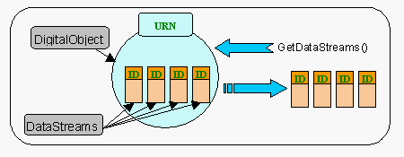

Accessing the DataStreams of a DigitalObject
DISSEMINATORS -- EXTENSIBLE INTERFACES TO DIGITAL OBJECTS
The basic set of structural operations described thus far is not sufficient to provide the rich functionality required by actual digital library users. While enabling interchangeability of data, these operations will not convey all of the information and semantics intended by object creators. Users from diverse communities should be able to interact with DigitalObjects in a familiar manner using "real world" metaphors such as books and diaries, or more esoteric objects such as programs or multimedia presentations. Architecturally, this means endowing DigitalObjects with operations that mimic the semantics of these abstractions. For example, once all the page images of a book are stored in a DigitalObject in one or more DataStreams, these images should be accessible through operations such as "turn the page" or "view the table of contents".
The architecture uses the abstraction of a Disseminator to associate these higher-level operations with DigitalObjects. Disseminators are used to extend the behavior of DigitalObjects, enabling clients to interact with them through semantically rich interfaces. Each Disseminator defines two classes of information. First, it defines a Disseminator Type (also known as a Signature), which is a set of operations that extends the functionality of a DigitalObject. Second, it defines a Servlet, which is a mechanism for producing the results (disseminations) of these operations. A given DigitalObject can have multiple Disseminators associated with it, in effect providing multiple "views" of the content in the DigitalObject.
A Figure depicts a DigitalObject with four underlying DataStreams linked to one of two Disseminators. The two Disseminators associate both "Book" and "DublinCore" functionality with the DigitalObject. Internally, each Disseminator references an appropriate Signature to assign additional operations to the DigitalObject (e.g., GetPage, GetChapter), and a Servlet to execute these operations. From the client perspective, these architectural details are hidden. Clients simply use generic RAP requests to discover and invoke these Book and DublinCore operations.
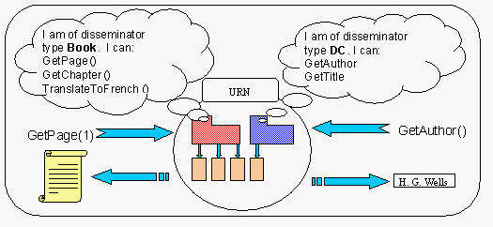
Accessing a Digital Object via Disseminators

DISSEMINATOR TYPES
A Disseminator Type is a set of operations that extends the basic functionality of a DigitalObject. These operations may or may not be directly related to the structure of a DigitalObject -- they may produce transformations of stored content. In the simple case, a book Disseminator may define operations such as "get the next page" and "get the table of contents." Such operations may disseminate pages as direct transcriptions of content stored in DataStreams. Other operations may be computational in nature. For example, a book Disseminator can provide operations such as "translate text" from French to English, or "create audio presentation" of the first 15 minutes of a book. In fact, operations can be totally dynamic (e.g., "get the current time").
Since new community-specific notions of content will continue to appear, there must be mechanisms for defining and registering new Disseminator Types. Communities can develop their own Disseminator Types (Signatures) by formally defining sets of operations that reflect the desired functionality of particular content abstractions. The codification of a Signature can be stored in a DigitalObject and given a unique name (a URN). Once stored, a Signature can be disseminated from the DigitalObject like any other form of content. Thus, DigitalObjects can be used to make Disseminator Types available in the infrastructure.
SERVLETS
A Servlet is an executable program that is capable of performing the set of operations defined for a specific Disseminator Type (identified by the URN of a stored Signature). Since the operations defined by a Disseminator Type may be derivable from a number of structural configurations, there may be multiple Servlets that "implement" a Disseminator Type. For example, a Servlet could be built to execute the operations associated with a book (e.g., "get the next page") using a set of scanned page images. Another Servlet could use an XML marked-up ASCII file. Thus, Disseminator Type equivalence is achieved when different Servlets operate on different types of underlying DataStreams to produce equivalent results.
In the same fashion as their associated Signature, Servlets are stored and registered in the infrastructure in their respective, uniquely named DigitalObjects. This design allows individuals to create new Servlets, store them in repositories, register their URNs (in the Handle System), and make them accessible for use in any other DigitalObjects.
EXTENSIBILITY
In summary, the key to the architecture's extensibility is the clean separation of the object structure, extensible interfaces (Disseminator Types), and the mechanisms that implement extended functionality. This scheme allows for the addition of new Disseminator Types at the repository infrastructure level. It also enables the evolution of DigitalObject functionality over time. Consider our example of a DigitalObject with a "Book" Disseminator. At a later time, the rights holder of this object could decide that the photographs in this book are of interest in their own right. To enable viewing of these photographs outside the context of the book, the owner of the object can endow the existing DigitalObject with additional functionality.
New interfaces can be added to existing DigitialObjects. In our example, a new Disseminator (e.g., of type PhotoCollection) can be associated with the original DigitalObject. The result is that the DigitalObject has both Book and PhotoCollection interfaces. The new Disseminator would reference a Servlet that allows a user to view the photographic images in the book as if they were part of a photo album. Such a Servlet would implement a "PhotoCollection" Disseminator Type using image detection and extraction techniques to present the images on demand (i.e., in response to a "get next photo" request). In short, DigitalObject behavior can be extended by (1) identifying or defining a Signature for the desired behaviors, and (2) acquiring or developing an appropriate Servlet for transforming content into the new "view."
OBJECTIVES

The objective of this is to introduce an approach to software design Where the design is structured as interacting objects. When you have read this chapter, you will: understand how a software design may be represented as a set of interacting objects that manage their own state and operations,

-  know the most important activities in a general object-oriented design process,
-   understand different models that may be used to document an object oriented
design,
-   have been introduced to the representation of these models in the
- Unified Modeling Language (UML).

INTRODUCTION

USE-CASE DIAGRAMS (OVERVIEW)

Use-case diagrams graphically depict system behavior (use cases). These diagrams present a high level view of how the system is used as viewed from an outsider’s (actor’s) perspective. A use-case diagram may depict all or some of the use cases of a system.

A use-case diagram can contain:

- actors ("things" outside the system)

- use cases (system boundaries identifying what the system should do)

- interactions or relationships between actors and use cases in the system including the associations, dependencies, and generalizations.

Use-case diagrams can be used during analysis to capture the system requirements and to understand how the system should work. During the design phase, you can use use-case diagrams to specify the behavior of the system as implemented.
You can display and modify the properties and relationships of a use case through the Use-Case Specification.

ACTIVITY DIAGRAM (OVERVIEW)

Activity diagrams provide a way to model the workflow of a business process. You can also use activity diagrams to model code-specific information such as a class operation. Activity diagrams are very similar to a flowchart because you can model a workflow from activity to activity. An activity diagram is basically a special case of a state machine in which most of the states are activities and most of the transitions are implicitly triggered by completion of the actions in the source activities. The main difference between activity diagrams and state charts is activity diagrams are activity centric, while state charts are state centric. An activity diagram is typically used for modeling the sequence of activities in a process, whereas a state chart is better suited to model the discrete stages of an object’s lifetime.

Activity diagrams can model many different types of workflows. For example, a company could use activity diagrams to model the flow for an approval of orders or to model the paper trail of invoices. An accounting firm could use activity diagrams to model any number of financial transactions. A software company could use activity diagrams to model a software development process.

State Machine Diagram Samples

- Activity Diagram Use Case Sample
- Modeling an Operation with an Activity Diagram Sample
- Robot Transmission Statechart Diagram Sample
- Using Swimlanes on an Activity Diagram Sample

Understanding Workflows

Each activity represents the performance of a group of actions in a workflow. Once the activity is complete, the flow of control moves to the next activity or state through a transition. If an outgoing transition is not clearly triggered by an event, then it is triggered by the completion of the contained actions inside the activity. A unique activity diagram feature is a swimlane that defines who or what is responsible for carrying out the activity or state. It is also possible to place objects on activity diagrams. The workflow stops when a transition reaches an end state.

You can attach activity diagrams to most model elements in the use case or logical views. Activity diagrams cannot reside within the component view.

Activity Diagram Tools

You can use the following tools on the activity diagram toolbox to model activity diagrams:

- Activities
- Decisions
- End State
- Object
- Object Flow
- Start State
- States
- Swimlanes
- Synchronizations
- Transitions

CLASSDIAGRAM (OVERVIEW)

The class diagram class allows you to add, retrieve and delete classes and categories to and from a class diagram. The class diagram class has a set of properties and methods that apply specifically to class diagrams. In addition, it inherits all diagram class properties and methods.

The following table describes the Diagram Class properties.

Property Description

Element Inherits all Element class properties
Documentation Specifies the documentation belonging to the diagram
ExternalDocuments Specifies the collection of external documents belonging to the diagram
Items Collection of items belonging to the diagram
ItemViews Collection of item views belonging to the diagram
Visible Determines diagram visibility
ZoomFactor Specifies the zoom factor of the diagram

The following table describes the Diagram Class methods.

Method Description

RoseObject Methods Inherits all RoseObject class methods
Element Methods Inherits all Element class methods
Activate Makes a diagram the currently active diagram in the application
AddExternalDocument Adds an external document object to a diagram
AddNoteView Adds a note view to a diagram
AddRelationView Adds a relation view object to a diagram
AutosizeAll Automatically resizes the item views (icons) on a diagram
CenterDiagramToView Centers a diagram over one of its RoseItemView objects
DeleteExternalDocument Deletes an external document object from a diagram
Exists Determines whether a specified diagram object exists

GetNoteViews Retrieves the note views belonging to a diagram
GetParentContext Returns the model element that contains the diagram
GetSelectedItems Retrieves the currently selected items from a diagram
GetViewFrom Retrieves a view from a diagram
Invalidate Redraws a diagram
IsActive Indicates whether the diagram is the currently active diagram in the application
Layout Draws a diagram
LayoutSelectedViews Rearranges the selected views on a diagram
RemoveItemView Removes a rose item view
RemoveNoteView Removes a note view from a diagram
Render Creates a Windows metafile and renders the diagram to the file

RenderEnhanced Creates an enhanced Windows metafile and renders the diagram to the file

RenderEnhancedTo
ClipBoard Renders the diagram in enhanced metafile format and stores it in the Clipboard

RenderToClipboard Renders the diagram in metafile format and stores it in the Clipboard

Update Updates a diagram

SEQUENCE DIAGRAMS (OVERVIEW)

A sequence diagram is a graphical view of a scenario that shows object interaction in a time-based sequence¾what happens first, what happens next. Sequence diagrams establish the roles of objects and help provide essential information to determine class responsibilities and interfaces. This type of diagram is best used during early analysis phases in design because they are simple and easy to comprehend. Sequence diagrams are normally associated with use cases.

Sequence diagrams are closely related to collaboration diagrams and both are alternate representations of an interaction. There are two main differences between sequence and collaboration diagrams: sequence diagrams show time-based object interaction while collaboration diagrams show how objects associate with each other.

A sequence diagram has two dimensions: typically, vertical placement represents time and horizontal placement represents different objects.
The following tools located on the sequence diagram toolbox enable you to model sequence diagrams:

- Object
- Message Icons
- Focus of Control
- Message to Self
- Note
- Note Anchor

COLLABORATION DIAGRAMS (OVERVIEW)

Collaboration diagrams and sequence diagrams are alternate representations of an interaction. A collaboration diagram is an interaction diagram that shows the order of messages that implement an operation or a transaction. A sequence diagram shows object interaction in a time-based sequence.

Collaboration diagrams show objects, their links, and their messages. They can also contain simple class instances and class utility instances. Each collaboration diagram provides a view of the interactions or structural relationships that occur between objects and object-like entities in the current model.

The Create Collaboration Diagram Command creates a collaboration diagram from information contained in the sequence diagram. The Create Sequence Diagram Command creates a sequence diagram from information contained in the interaction's collaboration diagram. The Goto Sequence Diagram and Goto Collaboration Diagram commands traverse between an interaction's two representations.

Collaboration diagrams contain icons representing objects. You can create one or more collaboration diagrams to depict interactions for each logical package in your model. Such collaboration diagrams are themselves contained by the logical package enclosing the objects they depict.

An Object Specification enables you to display and modify the properties and relationships of an object. The information in a specification is presented textually. Some of this information can also be displayed inside the icons representing objects in collaboration diagrams.

You can change properties or relationships by editing the specification or modifying the icon on the diagram. The associated diagrams or specifications are automatically updated.

Use Collaboration Diagrams To: Analysis Indicate the semantics of the primary and secondary interactions Design Show the semantics of mechanisms in the logical design of the system Use collaboration diagrams as the primary vehicle to describe interactions that express your decisions about the behavior of the system.

COMPONENT DIAGRAM

A component diagram shows the allocation of classes and objects to components in the physical design of a system. A component diagram may represent all or part of the component architecture of a system.

The dependency relationship indicates that one entity in a component diagram uses the services or facilities of another. Dependencies in the component diagram represent compilation dependencies. The dependency relationship may also be used to show calling dependencies among components, using dependency arrows from components to interfaces on other components.

Draw a dependency relationship between two classes, or between a class and an interface, to show that the client class depends on the supplier class/interface to provide certain services, such as:

- The client class accesses a value (constant or variable) defined in the supplier class/interface.

- Operations of the client class invoke operations of the supplier class/interface.

- Operations of the client class have signatures whose return class or arguments are instances of the supplier class/interface.

DEPLOYMENT DIAGRAMS (OVERVIEW)

A deployment diagram shows processors, devices, and connections. Each model contains a single deployment diagram which shows the connections between its processors and devices, and the allocation of its processes to processors.

Processor Specifications, Device Specifications, and Connection Specifications enable you to display and modify the respective properties. The information in a specification is presented textually; some of this information can also be displayed inside the icons. You can change properties or relationships by editing the specification or modifying the icon on the diagram. The deployment diagram specifications are automatically updated.

The deployment diagram collection class allows you to create and manipulate deployment diagram collections. For example, you can

- Add a deployment diagram to a deployment diagram collection
- Iterate through a deployment diagram collection in order to access a particular deployment diagram
- Delete a deployment diagram from a deployment diagram collection.
- Check the lists of properties and methods for complete information.

EX.NO:
PASSPORT AUTOMATION SYSTEM

DATE:
AIM:
To draw the diagrams[usecase, activity, sequence, collaboration, class] for the Passport automation system.

HARDWARE REQUIREMENTS:

- Intel Pentium Processor 3

SOFTWARE REQUIREMENTS:

- Rational rose

PROJECT DESCRIPTION:

This software is designed for the verification of the passport details of the applicant by the central computer. The details regarding the passport will be provided to the central computer and the computer will verify the details of applicant and provide approval to the office. Then the passport will issue from the office to the applicant.

USE CASE DIAGRAM:

This diagram will contain the actors, use cases which are given below

Actors: Applicant, Enquiry officer.
Use case: Applicant details, Applicant proof, Verification of proof, Issue of passport, Cancellation of the passport.

ACTIVITY DIAGRAM:

This diagram will have the activities as Start point ,End point, Decision boxes as given below:
Activities: Enter applicant details, Submission of proof, Verification of details, issue of passport.
Decision box: Check details whether it is correct or not.

CLASS DIAGRAM:
This diagram consists of the following classes, attributes and their operations.

CLASSES | ATTRIBUTES | OPERATIONS
Passport management system | Verify details, store proof | Verification of proof()
Enquiry officer | Applicant Details | Issue of passport()
Applicant | Name, details | Apply passport()

SEQUENCE DIAGRAM:

This diagram consists of the objects, messages and return messages.
Object: Applicant, Enquiry officer, Passport management system

COLLABORATION DIAGRAM:

This diagram contains the objects and actors. This will be obtained by the completion of the sequence diagram and pressing the F5 key.

MERITS:

- Provides convenience.
- Easy usage.
- User friendliness.

DEMERITS:

- Need computer knowledge

PASSPORT AUTOMATION SYSTEM

USE CASE DIAGRAM:

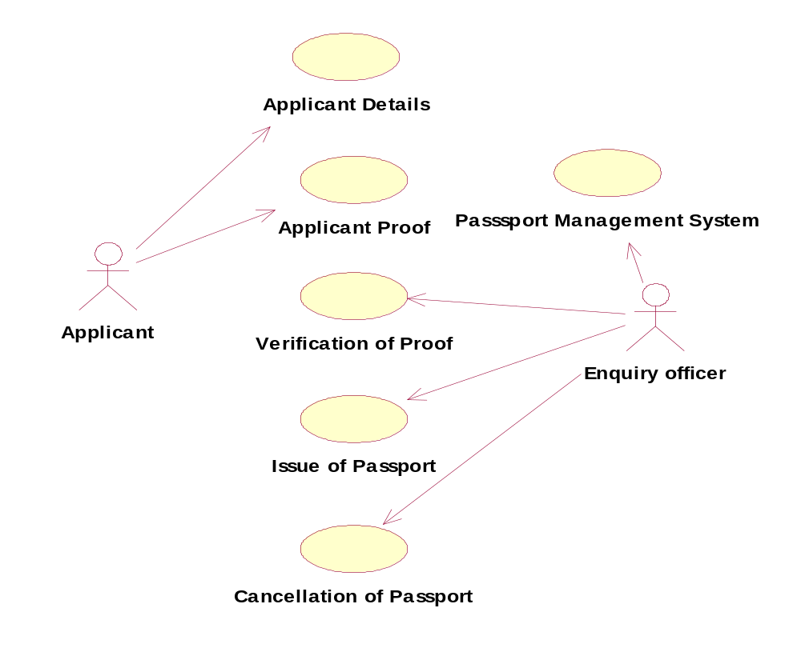

CLASS DIAGRAM:


Enquiry Officer
Verification of details
Issue of passport()
Renewal of passport()
Passport Management System
Verify details
Store proof
Issue of passport()
Verification of proof()
Cancellation of passport()
Applicant
Applicant name
Applicant details
Apply passport()
Submission of proof()

ACTIVITY DIAGRAM:

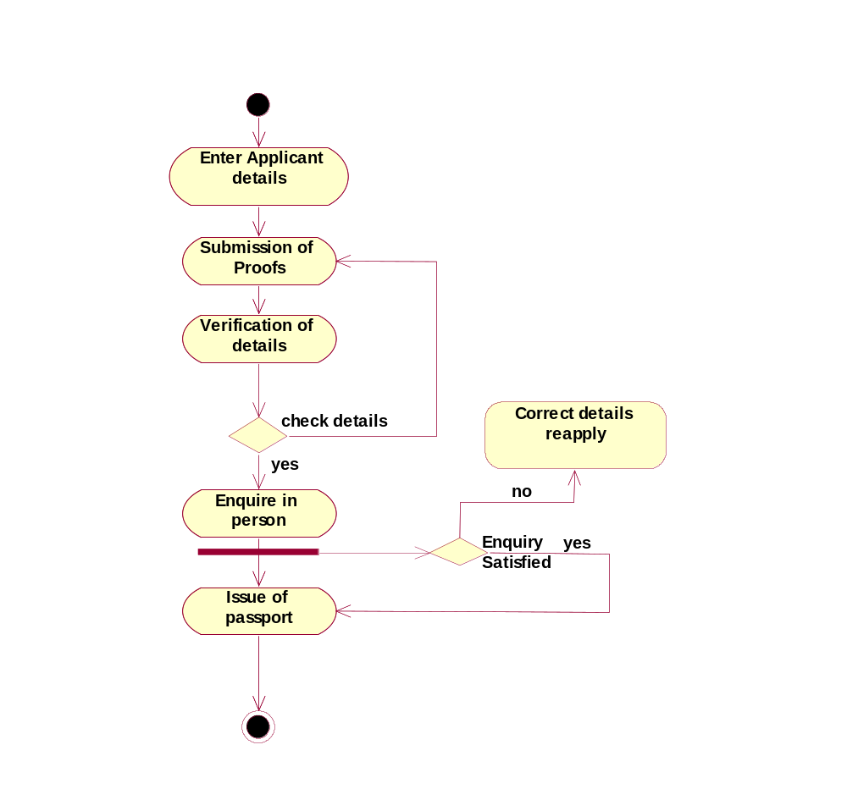

SEQUENCE DIAGRAM:

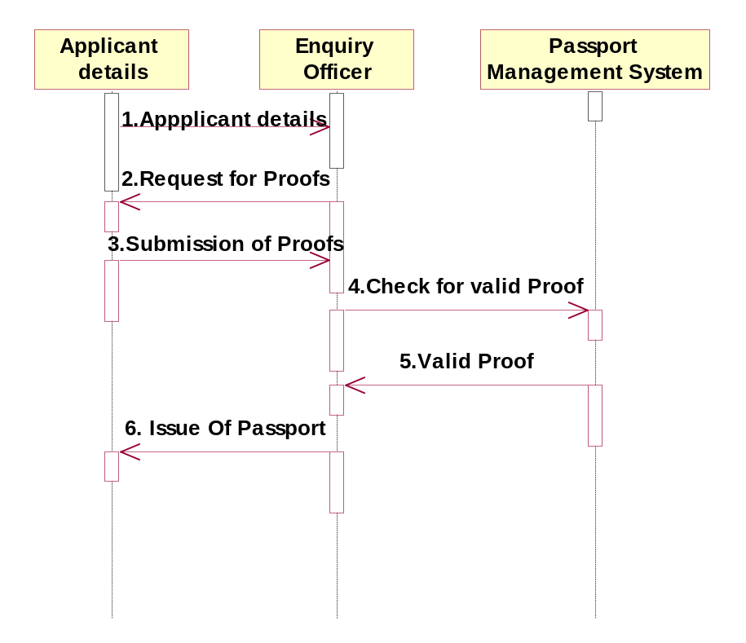

COLLABORATION DIAGRAM:

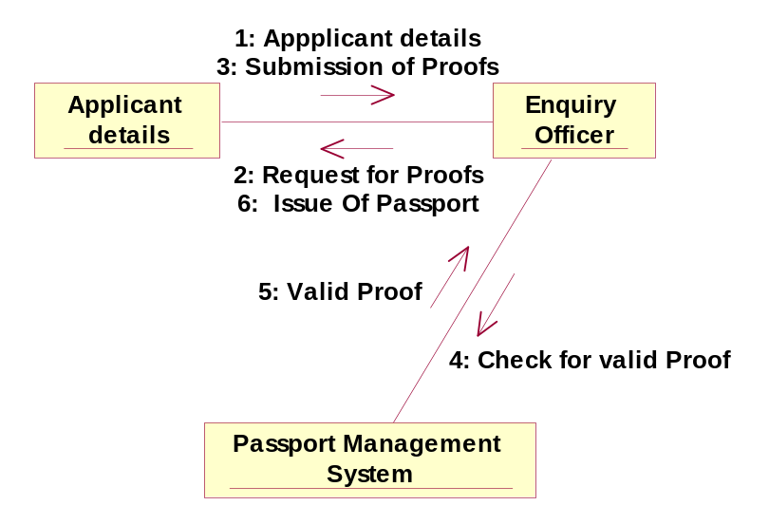

//Source file: Z:\\OOAD\\PassportManagementSystem.java

public class PassportManagementSystem
{
private int VerifyDetails;
private int StoreProof;

/**
@roseuid 4D2BEF7F022F
*/
public PassportManagementSystem()
{

}
/**
@roseuid 4D102E6900AB
*/
public void IssueOfPassport()

{
}

/**
@roseuid 4D102E87018E
*/
public void VerificationOfProof()
{

}

/**
@roseuid 4D102EA00368
*/
public void CancellationOfPassport()
{

}
}

//Source file: Z:\\OOAD\\EnquiryOfficer.java

public class EnquiryOfficer
{
private int VerificationOfDetails;
public PassportManagementSystem thePassportManagementSystem;

/**
@roseuid 4D2BEEEA0196
*/
public EnquiryOfficer()
{

}

/**
@roseuid 4D102ED5018E
*/

public void IssueOfPassport()
{

}

/**
@roseuid 4D102EE1004F
*/
public void RenewalOfPassport()
{

}
}

Result:

Thus the diagrams [Use case, class, activity, sequence, collaboration] for the passport automation system has been designed, executed and output is verified.

EX.NO:
BOOK BANK REGISTRATION SYSTEM
DATE:

AIM:
To draw the diagrams [use case, activity, sequence, collaboration, class] for the Book bank registration system.

HARDWARE REQUIREMENTS:

- Intel Pentium Processor 3

SOFTWARE REQUIREMENTS:

- Rational rose

PROJECT DESCRIPTION:

This software is designed for the verification of the details of the student by the central computer. The details regarding the student will be provided to the central computer through the administrator in the book bank and the computer will verify the details of student and provide approval to the office. Then the books that are needed by the student will issue from the office to the him.

USE CASE DIAGRAM:

This diagram will contain the actors, use cases which are given below

Actors: Student, book bank admin.
Use case: Student details, register, verify student id, and return previous books, request of books, issue of books, check of book availability.

ACTIVITY DIAGRAM:

This diagram will have the activities as Start point, End point, Decision boxes as given below:

Activities: Verify id, return books, request for books, enter book issue details in system, issue books

Decision box: Check availability of books whether it is present or not.

CLASS DIAGRAM:

This diagram consists of the following classes, attributes and their operations.

CLASSES | ATTRIBUTES | OPERATIONS
Computer | Student record, booklist | Enter issue(),check availability()
Stud | Student Details | Request for books(), register()
Admin | Student Details, book list | Verify student id(), issue books()

SEQUENCE DIAGRAM:

This diagram consists of the objects, messages and return messages.
Object: Stud, admin, computer

COLLABORATION DIAGRAM:

This diagram contains the objects and actors. This will be obtained by the completion of the sequence diagram and pressing the F5 key

MERITS:

- Provides convenience.
- Easily understandable.
- User friendliness.

DEMERITS:

- Need computer knowledge.
- It is complex for large scale products.

BOOK BANK RESISTRATION

USE CASE DIAGRAM:

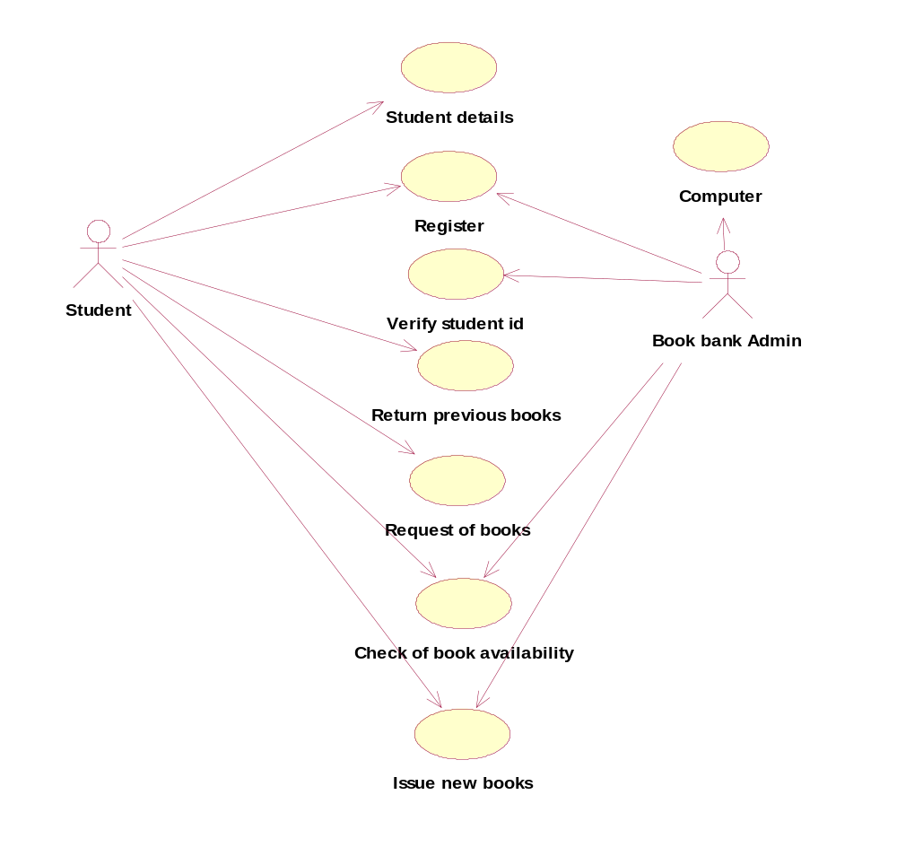

CLASS DIAGRAM:

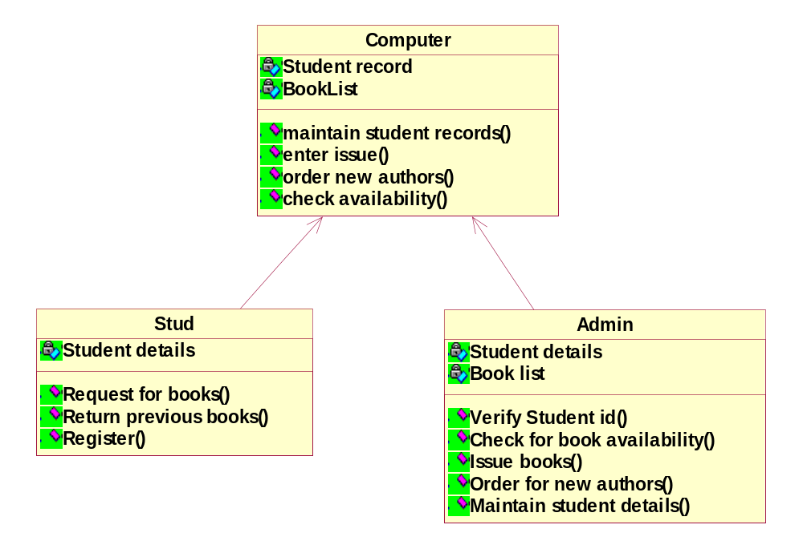

ACTIVITY DIAGRAM:

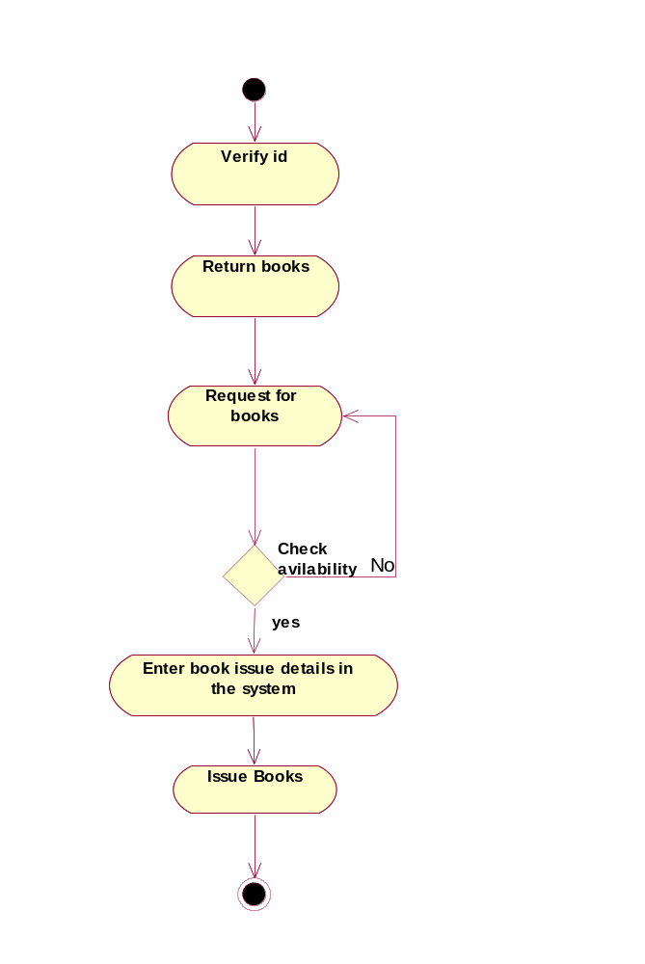

SEQUENCE DIAGRAM:

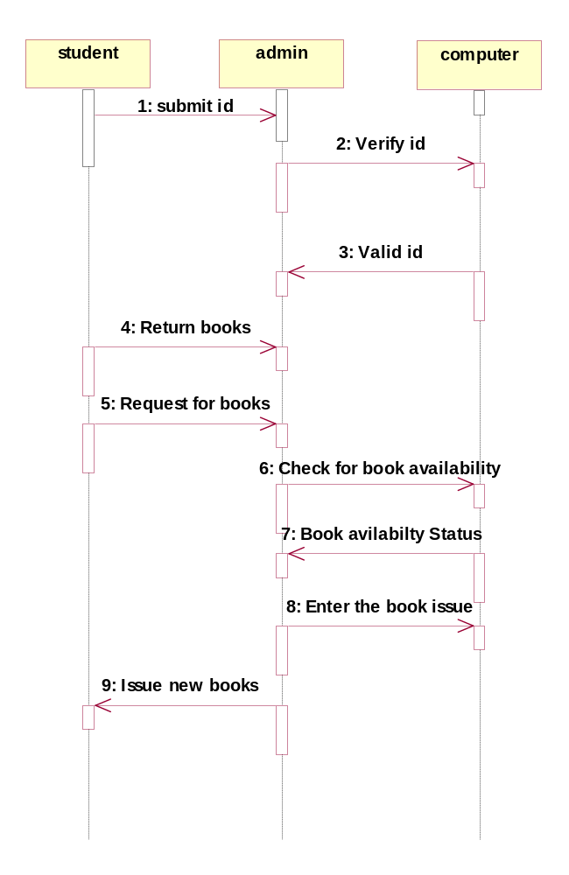\

COLLABORATION DIAGRAM:

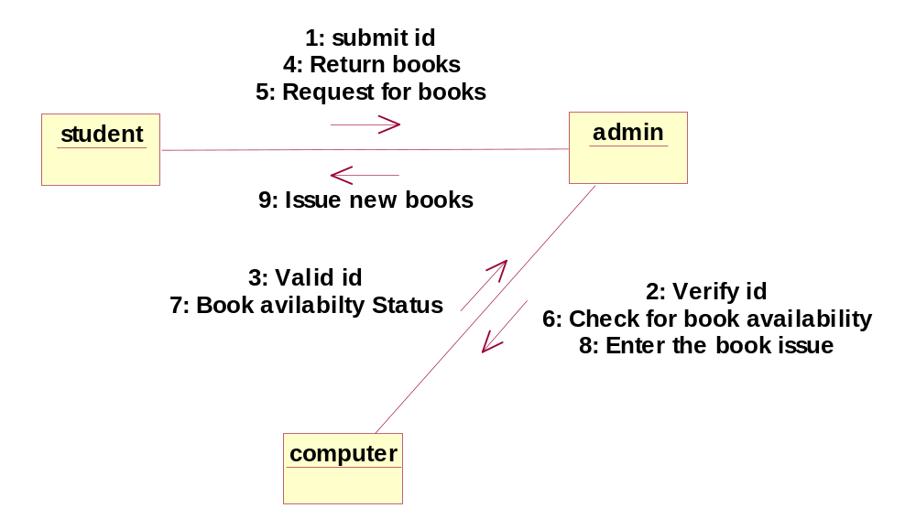

//Source file: Z:\\OOAD\\Computer.java

public class Computer
{
private int StudentRecord;
private int BookList;
public Admin theAdmin;

/**
* @roseuid 4D2BF06C0099
*/

public Computer()
{

}

/**
* @roseuid 4D1969AA0340
*/
public void maintainStudentRecords()
{

}

/**
* @roseuid 4D196A2A0003
*/
public void enterIssue()
{

}

/**
* @roseuid 4D196A5000A1
*/
public void orderNewAuthors()
{

}

/**
* @roseuid 4D196A5C0267
*/
public void checkAvailability()
{

}
}
//Source file: Z:\\OOAD\\Stud.java

public class Stud
{
private int StudentDetails;
public Computer theComputer;

/**
* @roseuid 4D2BF06C006A
*/
public Stud()
{

}

/**
* @roseuid 4D1041F8014F
*/
public void RequestForBooks()
{

}

/**
* @roseuid 4D1042050268
*/
public void ReturnPreviousBooks()
{

}

/**
* @roseuid 4D19698801A5
*/
public void Register()
{

}
}

Result:

Thus the diagrams [Use case, class, activity, sequence, collaboration] for the Book bank registration system has been designed, executed and output is verified.

EX.NO:
EXAM REGISTRATION SYSTEM
DATE:

AIM:
To draw the diagrams [use case, activity, sequence, collaboration, class] for the Exam registration system.

HARDWARE REQUIREMENTS:

- Intel Pentium Processor 3

SOFTWARE REQUIREMENTS:

- Rational rose

PROJECT DESCRIPTION:

This software is designed for the verification of the details of the candidate by the central computer. The details regarding the candidate will be provided to the central computer through the administrator and the computer will verify the details of candidate and provide approval .Then the hall ticket will be issued from the office to the candidate..

USE CASE DIAGRAM:

This diagram will contain the actors, use cases which are given below

Actors: Student, educational officer..
Use case: Student details, student photo, student proof submission of proof, verification of proof, payment of fees, and issue of hall ticket.

ACTIVITY DIAGRAM:

This diagram will have the activities as Start point, End point, Decision boxes as given below:
Activities: Enter student details, submit student proof and photo, payment of fees, issue of hall ticket.
Decision box: Verification of proof.

CLASS DIAGRAM:

This diagram consists of the following classes, attributes and their operations.

CLASSES | ATTRIBUTES | OPERATIONS
Central educational system | Student details | Print hall ticket(), issue hall ticket()
Stud | Submit details(),submit photo() | Payment of fees()
Eduofficer | Enter details | Issue hall ticket(), verify proof()

SEQUENCE DIAGRAM:

This diagram consists of the objects, messages and return messages.
Object: student, educational officer, central education system

COLLABORATION DIAGRAM:

This diagram contains the objects and actors. This will be obtained by the completion of the sequence diagram and pressing the F5 key.

MERITS:

- Provides convenience for issuing the hall ticket for the candidate.
- Processing the request will be fast.

DEMERITS:

- Need computer knowledge.

EXAM REGISTRATION

USE CASE DIAGRAM:

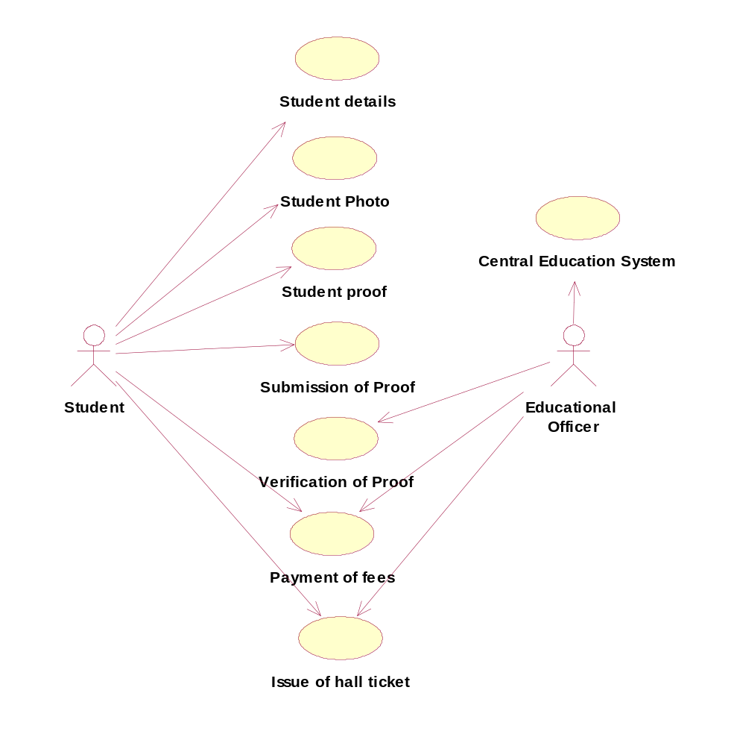

CLASS DIAGRAM:

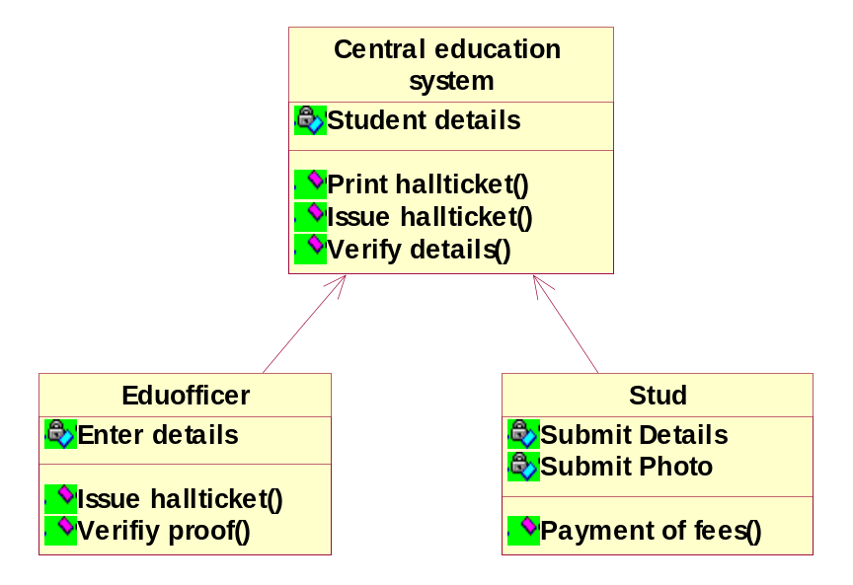

ACTIVITY DIAGRAM:

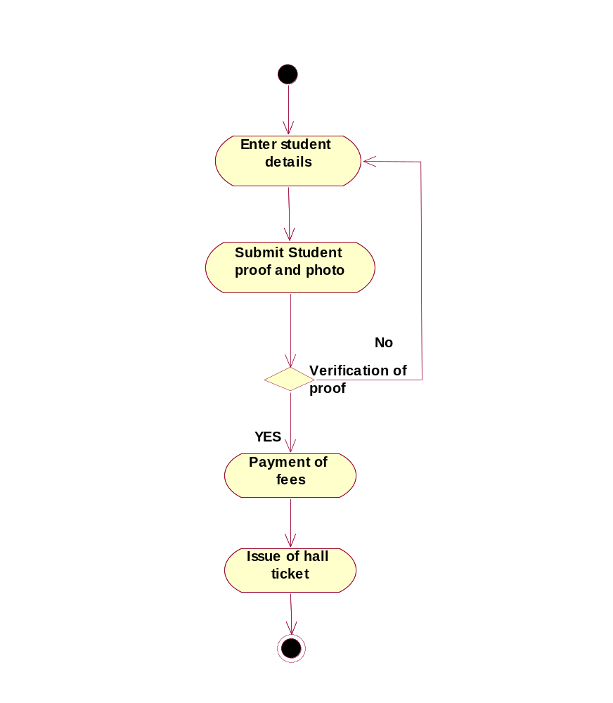

SEQUENCE DIAGRAM:

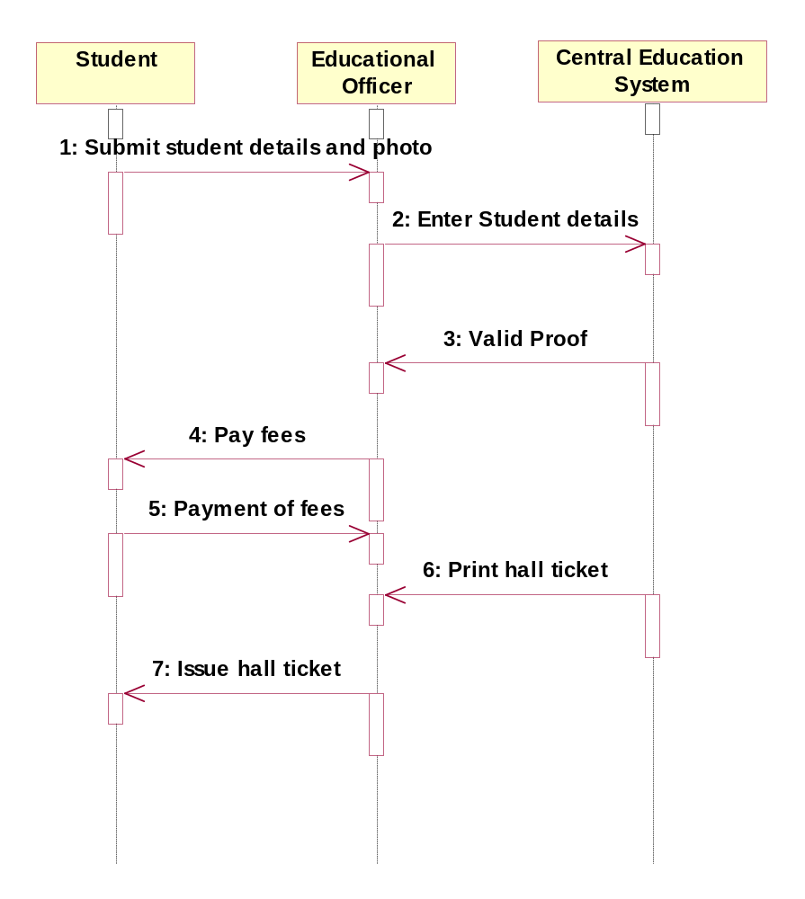

COLLABORATION DIAGRAM:

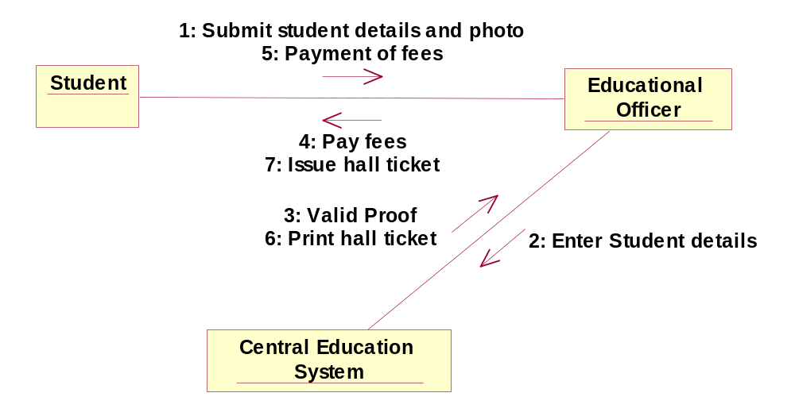

//Source file: Z:\\ooad\\Eduofficer.java

public class Eduofficer
{
private int EnterDetails;
public CentralEducationSystem theCentralEducationSystem;

/**
* @roseuid 4D2BF11403E4
*/
public Eduofficer()
{

}

/**
* @roseuid 4D22A8F20166
*/
public void IssueHallticket()
{

}

/**
* @roseuid 4D22A9030011
*/
public void VerifiyProof()
{

}

//Source file: Z:\\ooad\\CentralEducationSystem.java

public class CentralEducationSystem
{
private int StudentDetails;

/**
* @roseuid 4D2BF11800C8
*/
public CentralEducationSystem()
{

}

/**
* @roseuid 4D22A86B0276
*/
public void PrintHallticket()
{

}

/**
* @roseuid 4D22A8740381
*/
public void IssueHallticket()
{

}

/**
* @roseuid 4D22B2B60048
*/
public void VerifyDetails()
{

}
}
}

Result:

Thus the diagrams [Use case, class, activity, sequence, collaboration] for the Exam registration system has been designed, executed and output is verified.

EX.NO:
STOCK MAINTAINENCE SYSTEM

DATE:

AIM:
To draw the diagrams [use case, activity, sequence, collaboration, class] for the Stock maintenance system.

HARDWARE REQUIREMENTS:

- Intel Pentium Processor 3

SOFTWARE REQUIREMENTS:

- Rational rose

PROJECT DESCRIPTION:

This software is designed for supporting the computerized stock maintainence
System .In this system, the customer can place order and purchase items with the aid of the stock dealer and central stock system. These orders are verified and the items are delivered to the customer.

USE CASE DIAGRAM:

This diagram will contain the actors, use cases which are given below

Actors: Customer, Stock dealer, central stock system.
Use case: purchase order, verification of order, payment, delivery of items..

ACTIVITY DIAGRAM:

This diagram will have the activities as Start point, End point, Decision boxes as given below:
Activities: Purchase order, payment, and delivery of items.
Decision box: Valid or not

CLASS DIAGRAM:

This diagram consists of the following classes, attributes and their operations.

CLASSES | ATTRIBUTES | OPERATIONS
Central stock system | Store stock details | Print bill()
Stock dealer | Take order | Deliver item()
Customer | Place order | Payment()

SEQUENCE DIAGRAM:

This diagram consists of the objects, messages and return messages.
Object: Customer, Stock dealer, Central stock system

COLLABORATION DIAGRAM:

This diagram contains the objects and actors. This will be obtained by the completion of the sequence diagram and pressing the F5 key.

MERITS:

- Provides convenience.
- Easy usage.
- User friendliness.

DEMERITS:

- Need computer knowledge

STOCK MAINTAINENCE SYSTEM

USE CASE DIAGRAM:

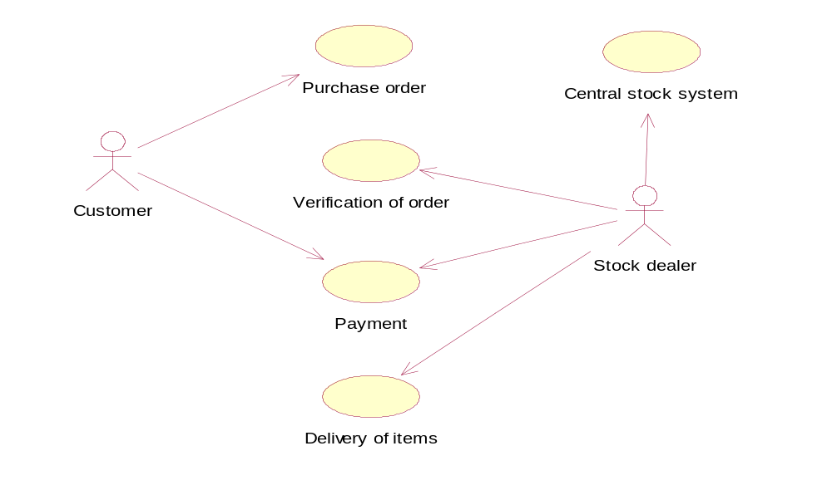

CLASS DIAGRAM:

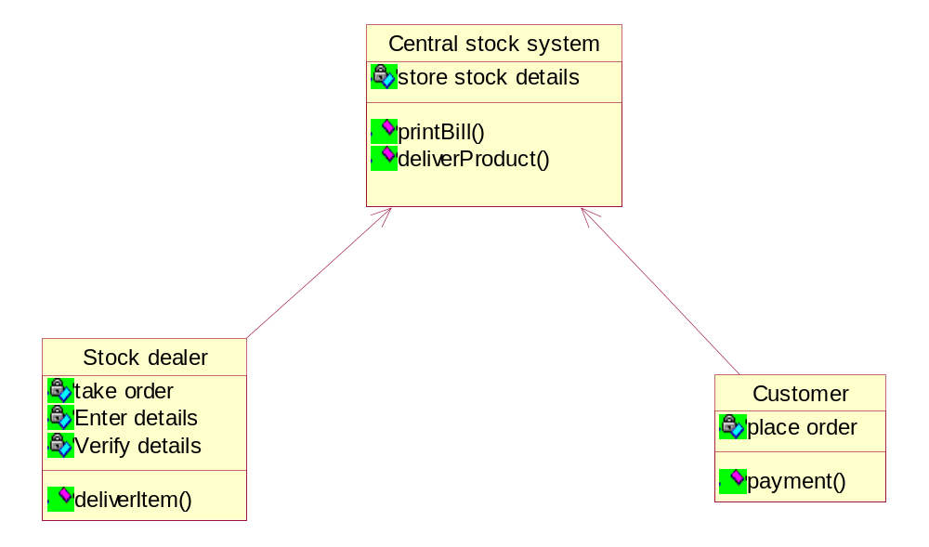

ACTIVITY DIAGRAM:
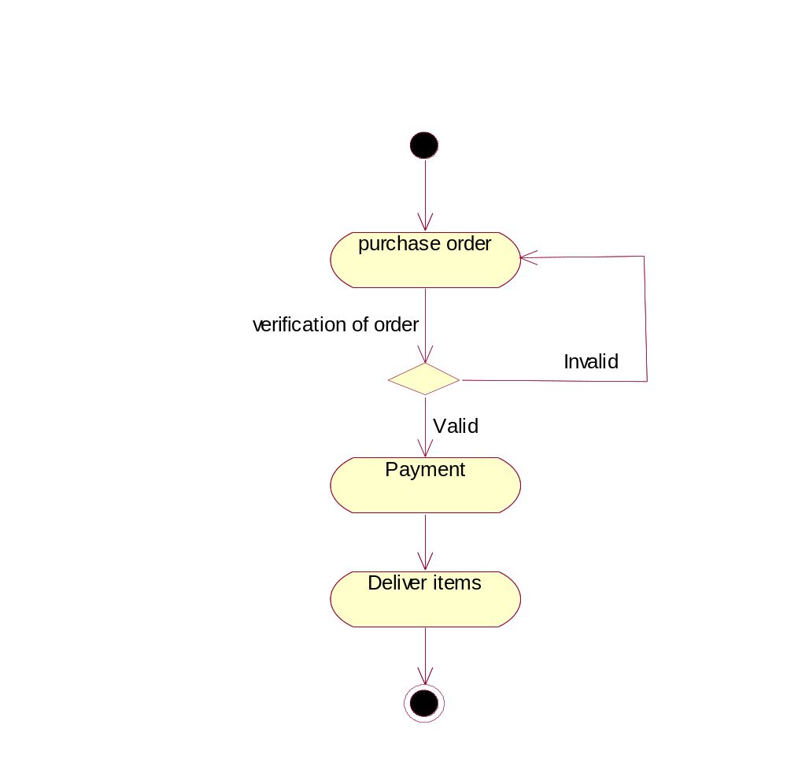

COLLABORATION DIAGRAM:

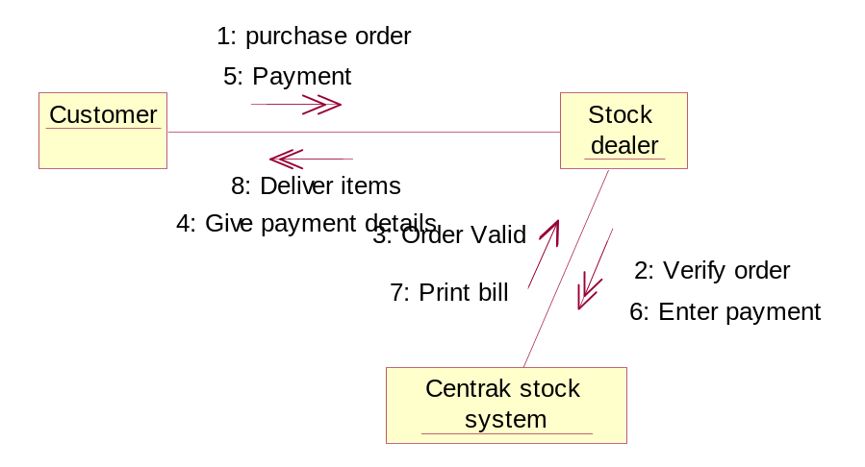

SEQUENCE DIAGRAM:

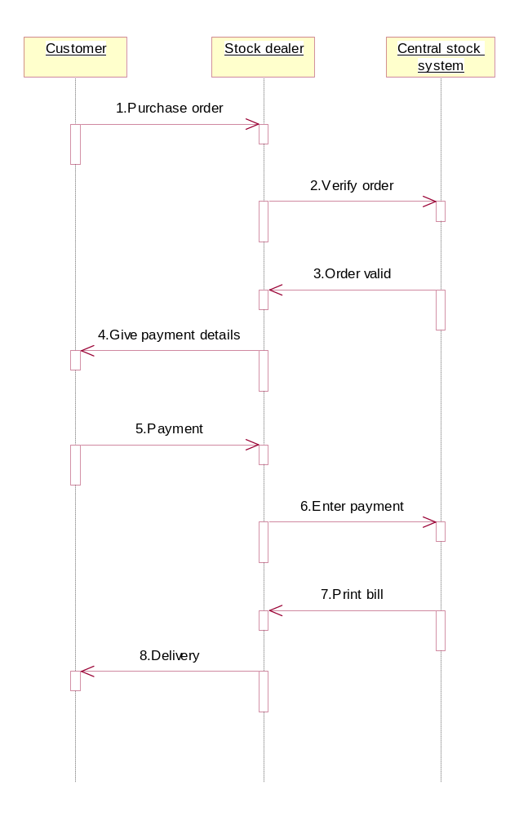

//Source file: Z:\\OOAD\\Customer.java

public class Customer
{
private int placeOrder;
public CentralStockSystem theCentralStockSystem;

/**
@roseuid 4D35369303CB
*/
public Customer()
{

}

/**
@roseuid 4D2BF868030D
*/
public void payment()
{

}
}

RESULT:

Thus the diagrams [Use case, class, activity, sequence, collaboration] for the Stock maintenance system has been designed, executed and output is verified.

EX.NO:
ONLINE COURSE RESERVATION SYSTEM
DATE:

AIM:
To draw the diagrams [use case, activity, sequence, collaboration, class] for the Online course reservation system.

HARDWARE REQUIREMENTS:

- Intel Pentium Processor 3

SOFTWARE REQUIREMENTS:

- Rational rose

PROJECT DESCRIPTION:

This software is designed for supporting online course reservation system. This system is organized by the central management system . The student first browses and select the desired course of their choice. The university then checks the availability of the seat if it is available the student is enrolled for the course.

USE CASE DIAGRAM:

This diagram will contain the actors, use cases which are given below
Actors: Student, University.
Use case: Browse course, select course, register, submit details, verify details, pay fees, enroll student..

ACTIVITY DIAGRAM:

This diagram will have the activities as Start point ,End point, Decision boxes as given below:
Activities: Browse course, select course, register course, submit details
Decision box: check availability or not

CLASS DIAGRAM:

This diagram consists of the following classes, attributes and their operations.

CLASSES | ATTRIBUTES | OPERATIONS
Central management system | Store details | Verify()
Student | Name and address | Browse()
University | Store details | Verify()

SEQUENCE DIAGRAM:

This diagram consists of the objects, messages and return messages.
Object: Student, University, Central management system

COLLABORATION DIAGRAM:

This diagram contains the objects and actors. This will be obtained by the completion of the sequence diagram and pressing the F5 key.

MERITS:

- Provides convenience.
- Easy usage.
- User friendliness.

DEMERITS:

Need computer knowledge

ONLINE COURSE RESERVATION SYSTEM

USE CASE DIAGRAM:

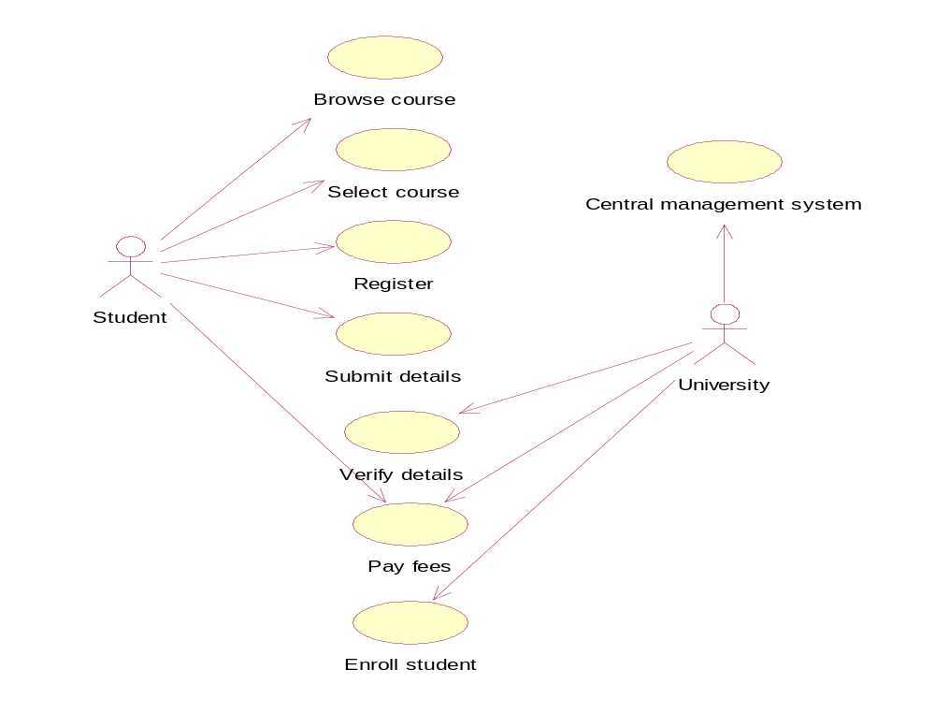
CLASS DIAGRAM:

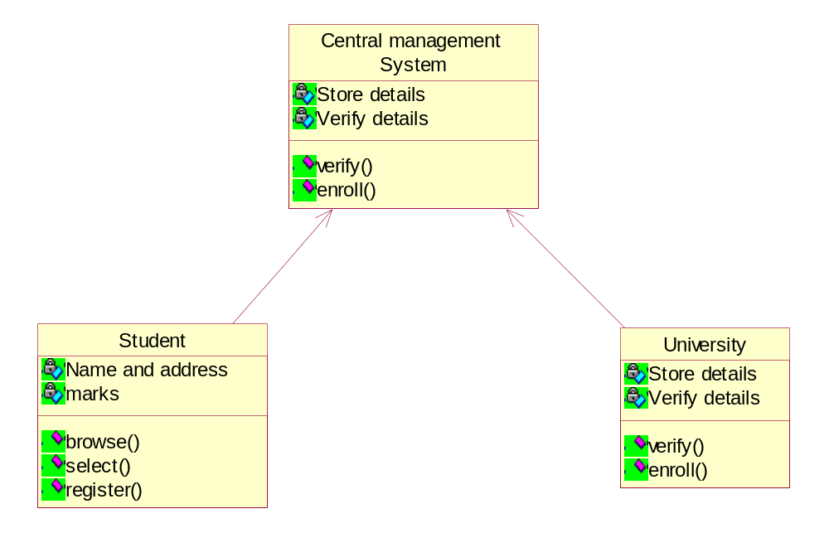

ACTIVITY DIAGRAM:
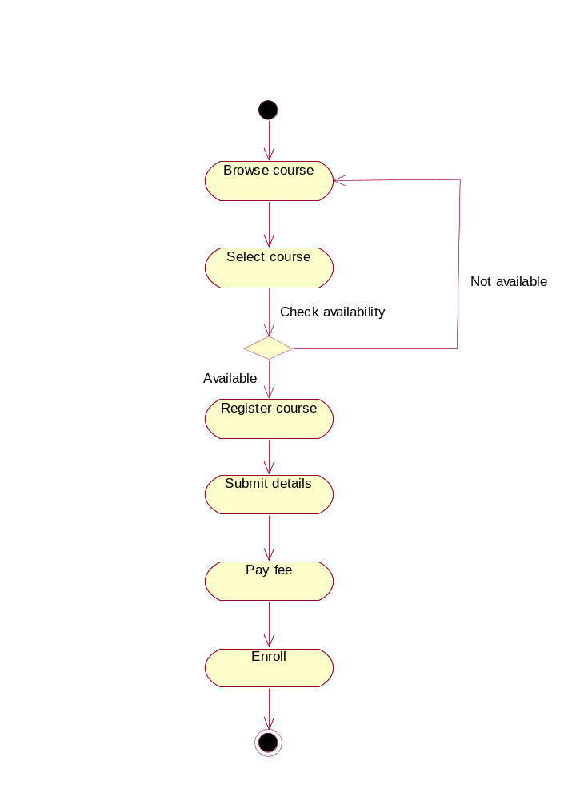

SEQUENCE DIAGRAM:

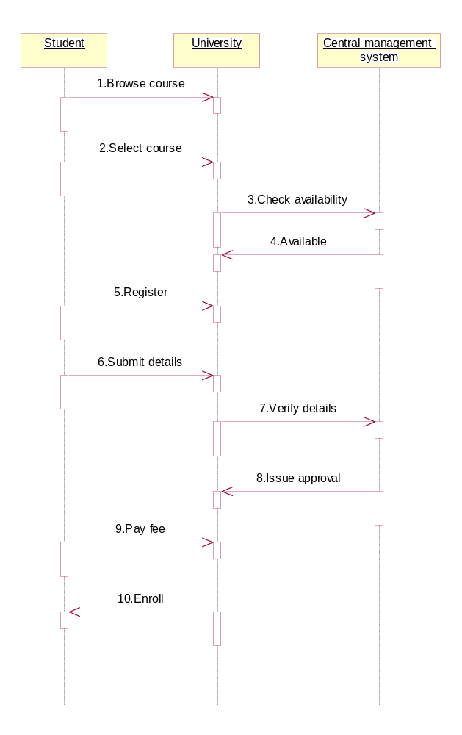

COLLABORATION DIAGRAM:

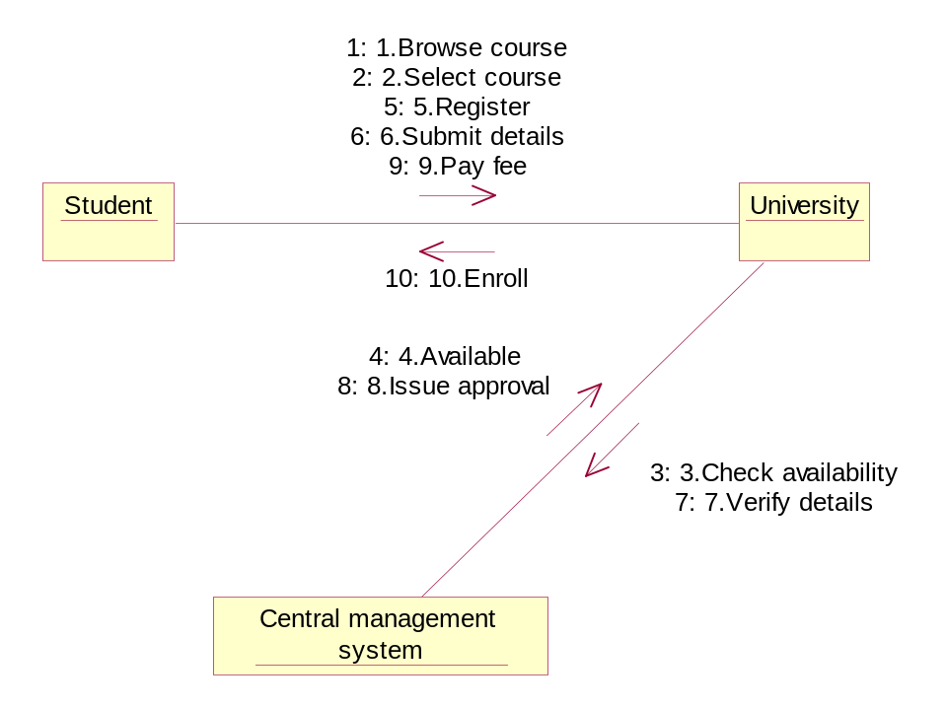

//Source file: Z:\\OOAD\\CentralManagementSystem.java

public class CentralManagementSystem
{
private int StoreDetails;
private int VerifyDetails;

/**
@roseuid 4D352E090304
*/
public CentralManagementSystem()
{

}

/**
@roseuid 4D3517FA013F
*/
public void verify()
{

}

/**
@roseuid 4D3518030380
*/
public void enroll()
{

}
}

RESULT:

Thus the diagrams [Use case, class, activity, sequence, collaboration] for the online course reservation system has been designed, executed and output is verified.

EX.NO:
E-TICKETING
DATE:

AIM:
To draw the diagrams [use case, activity, sequence, collaboration, class] for the
E-ticketing system.

HARDWARE REQUIREMENTS:

- Intel Pentium Processor 3

SOFTWARE REQUIREMENTS:

- Rational rose

PROJECT DESCRIPTION:

This software is designed for supporting the computerized e-ticketing. This is widely used by the passenger for reserving the tickets for their travel. This E-ticketing is organized by the central system. The information is provided from the railway reservation system.

USE CASE DIAGRAM:

This diagram will contain the actors, use cases which are given below

Actors: Passenger, Railway reservation system..
Use case: Status, reservation, cancellation, enter the train number, enter the number of seats, availability of seats, and acceptance of ticket.

ACTIVITY DIAGRAM:

This diagram will have the activities as Start point, End point, Decision boxes as given below:
Activities: enter the train number, enter the number of seats, acceptance of ticket, accept seat.
Decision box: Check availability of seats whether it is present or not.

CLASS DIAGRAM:

This diagram consists of the following classes, attributes and their operations.

CLASSES | ATTRIBUTES | OPERATIONS
Central computer | Train name, passenger name | Reservation(),login()
Passenger | Passenger age | Login()
R\ailway reservation system | Train number | Cancellation()

SEQUENCE DIAGRAM:

This diagram consists of the objects, messages and return messages.
Object: Passenger, Railway reservation system, Central computer

COLLABORATION DIAGRAM:

This diagram contains the objects and actors. This will be obtained by the completion of the sequence diagram and pressing the F5 key.

MERITS:

- Provides convenience.
- Easily understandable.
- User friendliness.

DEMERITS:

- Need computer knowledge.
- It is complex for large scale products.

E-TICKETING

USE CASE DIAGRAM:

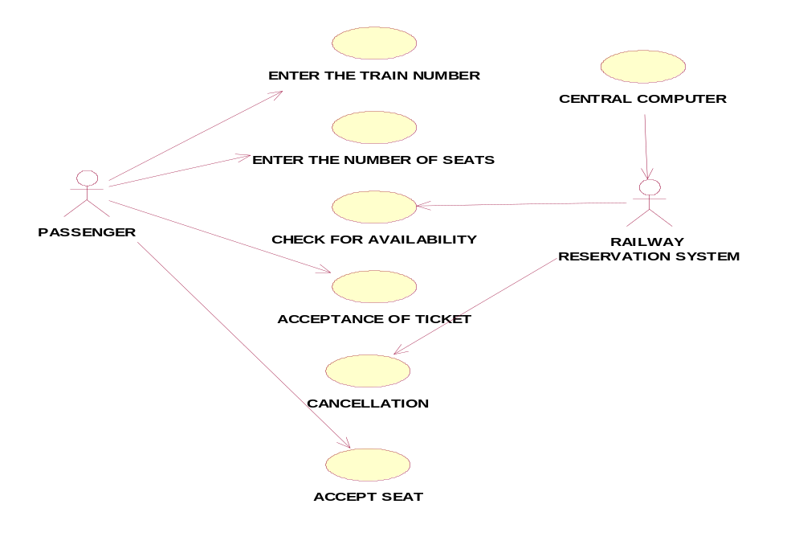CLASS DIAGRAM:
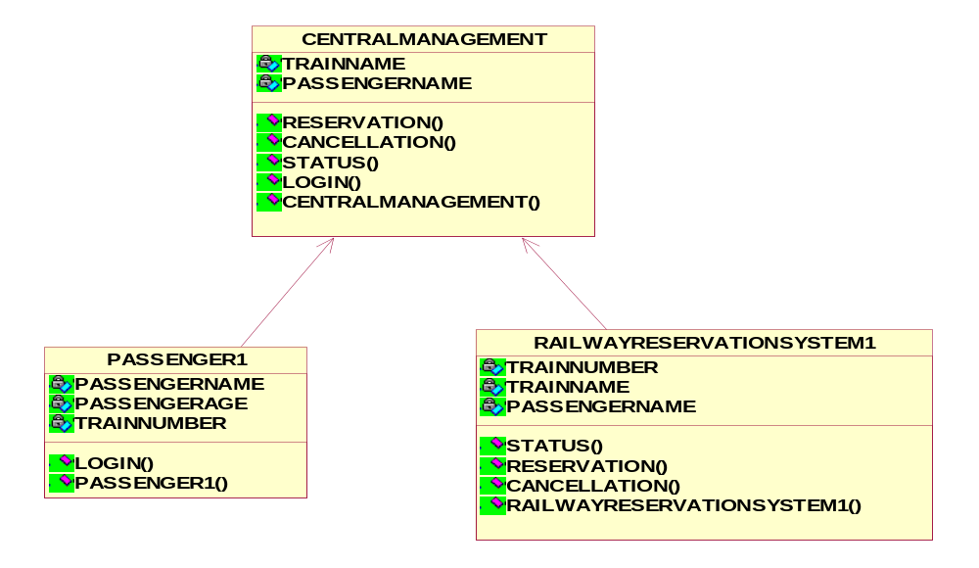

ACTIVITY DIAGRAM:

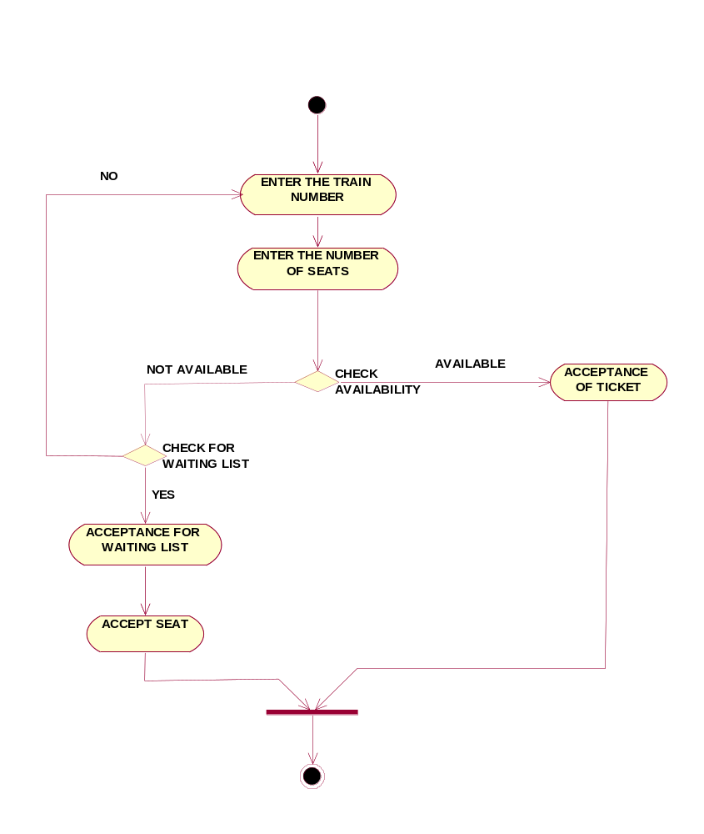

SEQUENCE DIAGRAM:

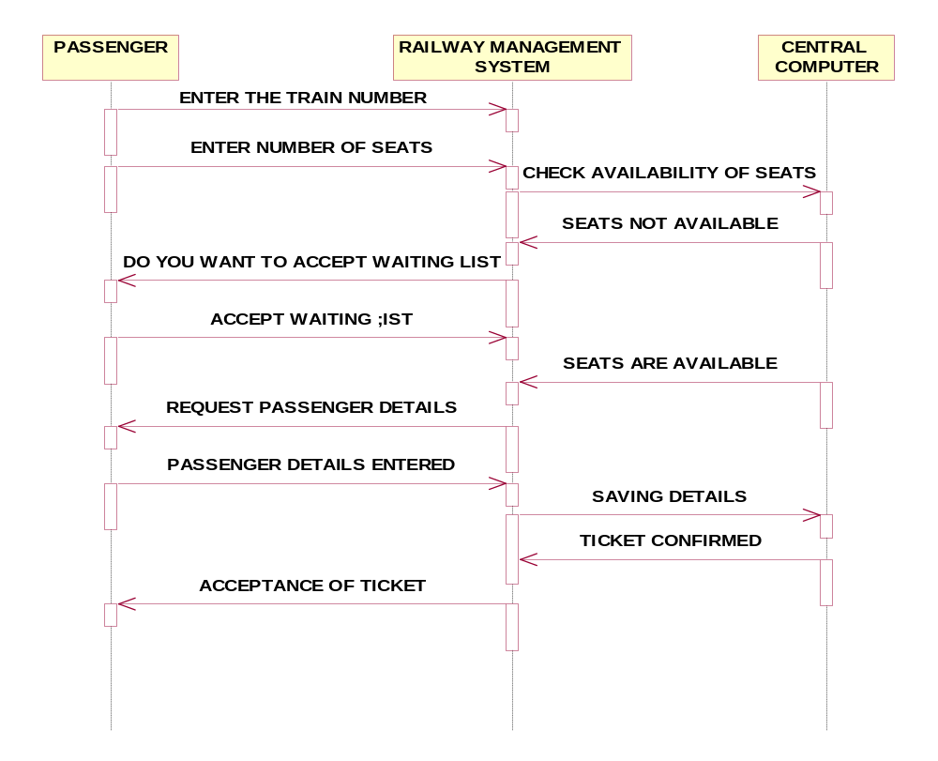
COLLABORATION DIAGRAM:

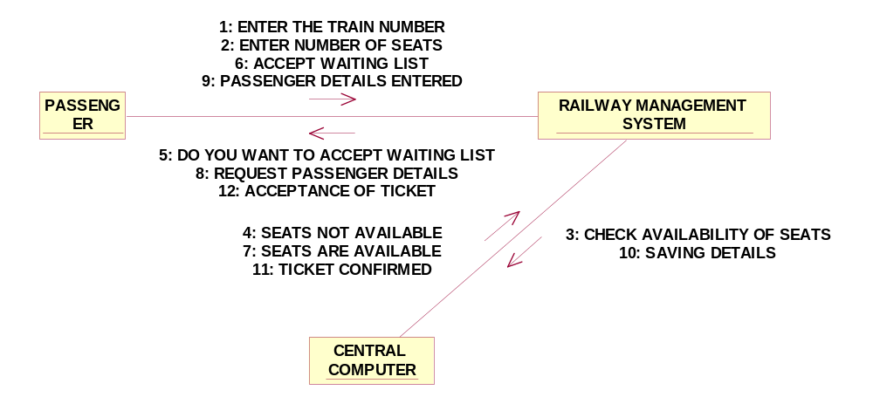

//Source file: Z:\\3CSEB34\\railwayManagementSystem.java

public class railwayManagementSystem
{
private int trainNo;
private int trainName;
private int name;
public centralcomputer theCentralcomputer;

/**
@roseuid 4D3E69DF014C
*/
public railwayManagementSystem()
{

}
/**
@roseuid 4D3E59590350
*/
public void status()
{

}

/**
@roseuid 4D3E596702A4
*/
public void reservation()
{

}

/**
@roseuid 4D3E596F03AE
*/
public void cancellation()
{

}
}
//Source file: Z:\\3CSEB34\\centralcomputer.java

public class centralcomputer
{
private int trainName;
private int passengerName;

/**
@roseuid 4D3E698501C7
*/
public centralcomputer()
{

}

/**
@roseuid 4D3E588F01BD
*/
public void cancellation()
{

}

/**
@roseuid 4D3E58A80113
*/
public void status()
{

}

/**
@roseuid 4D3E58B60366
*/
public void login()
{
}}

RESULT:

Thus the diagrams [Use case, class, activity, sequence, collaboration] for the E-ticketing has been designed, executed and output is verified.

EX.NO:
CREDIT CARD PROCESSING
DATE:

AIM:
To draw the diagrams [usecase, activity, sequence, collaboration, class] for Credit Card Processing

HARDWARE REQUIREMENTS:

- Intel Pentium Processor 3

SOFTWARE REQUIREMENTS:

- Rational rose

PROJECT DESCRIPTION:

This software is designed for supporting the computerized credit card processing
System .In this system, the cardholder purchases items and pays bill with the aid of the credit card. The cashier accepts the card and proceeds for transaction using the central system. The bill is verified and the items are delivered to the cardholder.

USE CASE DIAGRAM:

This diagram will contain the actors, use cases which are given below

Actors: Cardholder, Cashier, Central system.
Use case: Receive bill, Give card, Enter card number, Enter amount, Transaction, Receive Receipt

ACTIVITY DIAGRAM:

This diagram will have the activities as Start point, End point, Decision boxes as given below:

Activities: Receive Bill, Give card, Enter the card number, Enter the amount, Transaction, Receive Receipt
Decision box: Verification of card

CLASS DIAGRAM:

This diagram consists of the following classes, attributes and their operations.

CLASSES | ATTRIBUTES | OPERATIONS
Central system | Product name  Product details | Print bill()  Validate card()
Cashier | Product name  Cost of the product | Enter amount()  Swipe Card()  Print Bill()  Deliver Product()
CardHolder | Items Purchased  Validate Card | Give card()  Sign bill()

SEQUENCE DIAGRAM:

This diagram consists of the objects, messages and return messages.
Object: Card Holder,Cashier , Central system

COLLABORATION DIAGRAM:

This diagram contains the objects and actors. This will be obtained by the completion of the sequence diagram and pressing the F5 key.

MERITS:

- Provides convenience.
- Easily understandable.
- User friendliness.

DEMERITS:

- Need computer knowledge.
- It is complex for large scale products.

CREDIT CARD PROCESSING

USE CASE DIAGRAM:

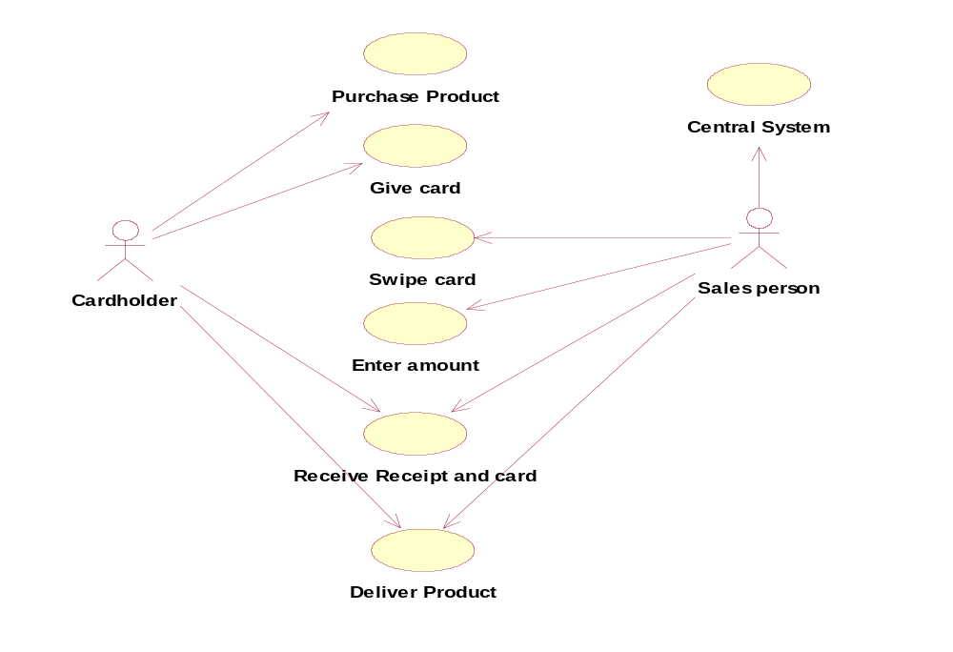

CLASS DIAGRAM:

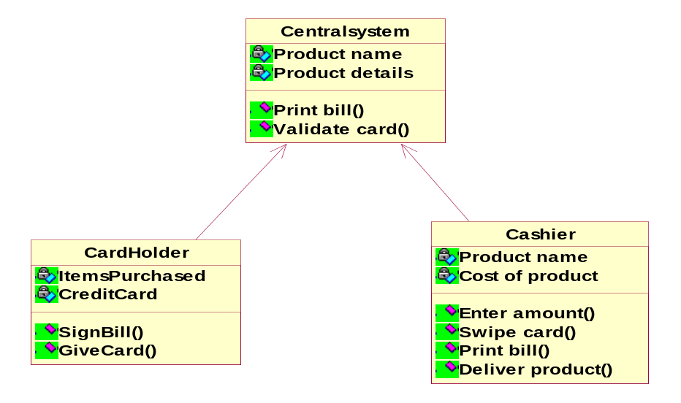

ACTIVITY DIAGRAM:

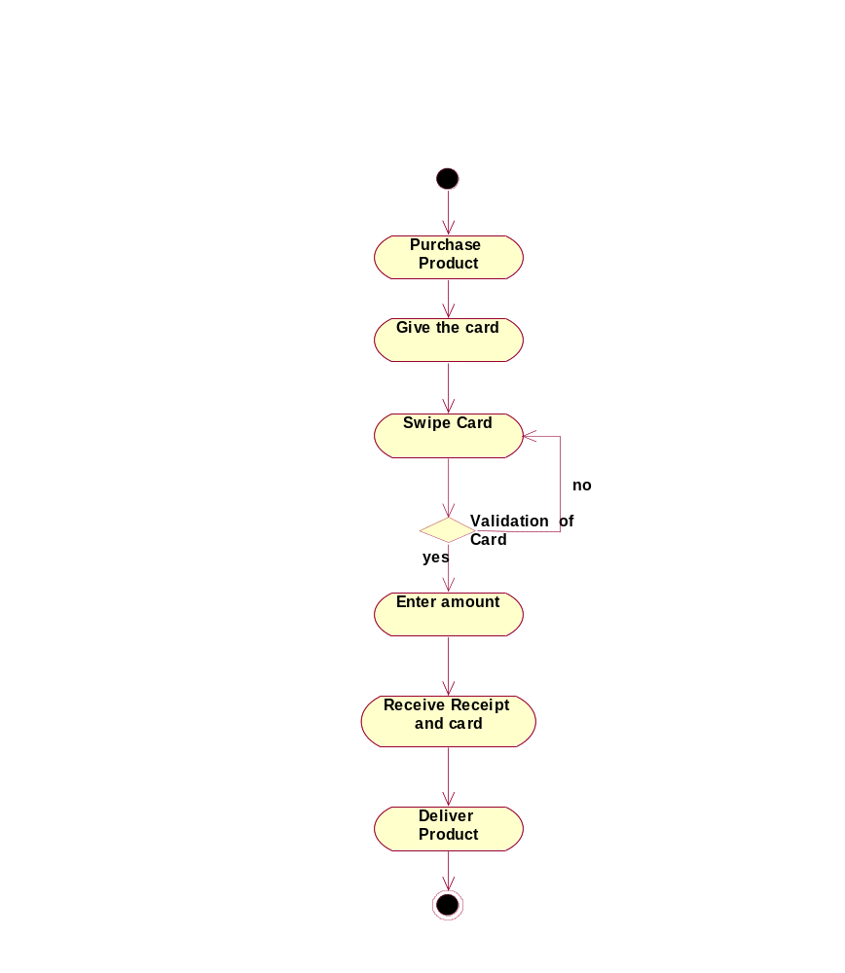

SEQUENCE DIAGRAM:

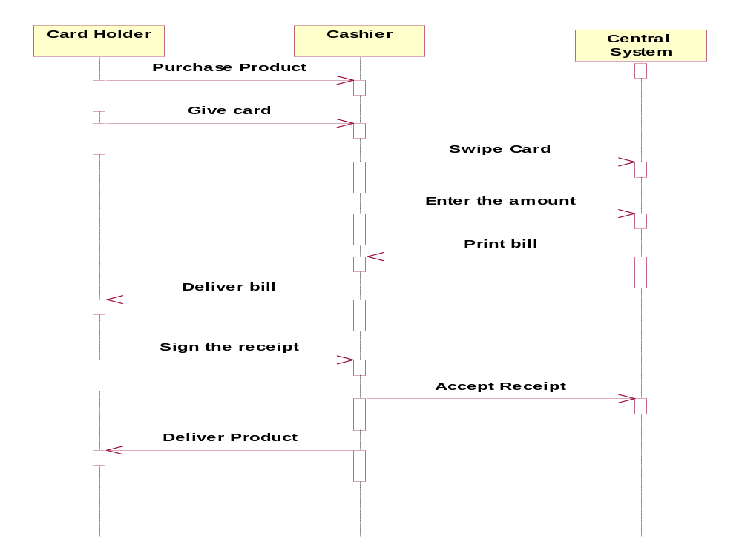

COLLABORATION DIAGRAM

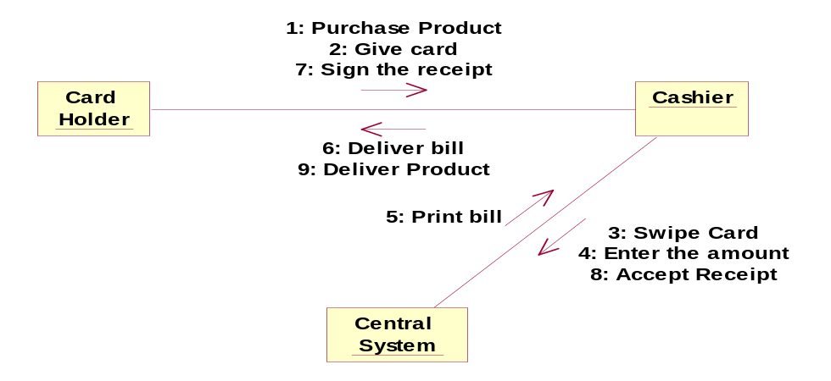

//Source file: Z:\\ooad\\Cashier.java
public class Cashier
{
private int ProductName;
private int CostOfProduct;
public Centralsystem theCentralsystem;
/**
@roseuid 4D47A1F001C6
*/
public Cashier()
{
}
/**
@roseuid 4D479612034A
*/
public void EnterAmount()
{
}
/**
@roseuid 4D47961602DD
*/
public void SwipeCard()
{
}
/**
@roseuid 4D47961C0167
*/
public void PrintBill()
{
}
/**
@roseuid 4D47962102DE
*/
public void DeliverProduct()
{
}
}

RESULT:

Thus the diagrams [Use case, class, activity, sequence, collaboration] for Credit Card Processing has been designed, executed and output is verified.

EX.NO:
SOFTWARE PERSONNEL MANAGEMENT SYSTEM
DATE:

AIM:
To draw the diagrams [usecase, activity, sequence, collaboration, class] for Software personnel management system

HARDWARE REQUIREMENTS:

- Intel Pentium Processor 3

SOFTWARE REQUIREMENTS:

- Rational rose

PROJECT DESCRIPTION:

This software is designed for the process of knowing the details of a person works in a software company. The details are being stored in the central management system for the crosschecking the person’s details.

USE CASE DIAGRAM:

This diagram will contain the actors, use cases which are given below
Actors: Employee, HR, Central system.
Use case: Name and address ,qualification ,experience, internet, loan, verification

ACTIVITY DIAGRAM:

This diagram will have the activities as Start point ,End point, Decision boxes as given below:

Activities: Enter the option to check, enter the salary, enter the working days ,leave taken ,loss of pay
Decision box: Option to check

CLASS DIAGRAM:

This diagram consists of the following classes, attributes and their operations.

CLASSES | ATTRIBUTES | OPERATIONS
Central management system | Employeename, Employeenumber | Tax()  Loan()
Employee1 | Employee details | Leave taken()
HR | checkdetails | Loss of pay()

SEQUENCE DIAGRAM:

This diagram consists of the objects, messages and return messages.
Object :Employee, HR, Central system

COLLABORATION DIAGRAM:

This diagram contains the objects and actors. This will be obtained by the completion of the sequence diagram and pressing the F5 key.

MERITS:

- Provides convenience.
- Easily understandable.
- User friendliness.

DEMERITS:

- Need computer knowledge.
- It is complex for large scale products.

SOFTWARE PERSONNEL MANAGEMENT SYSTEM.

USE CASE DIAGRAM:

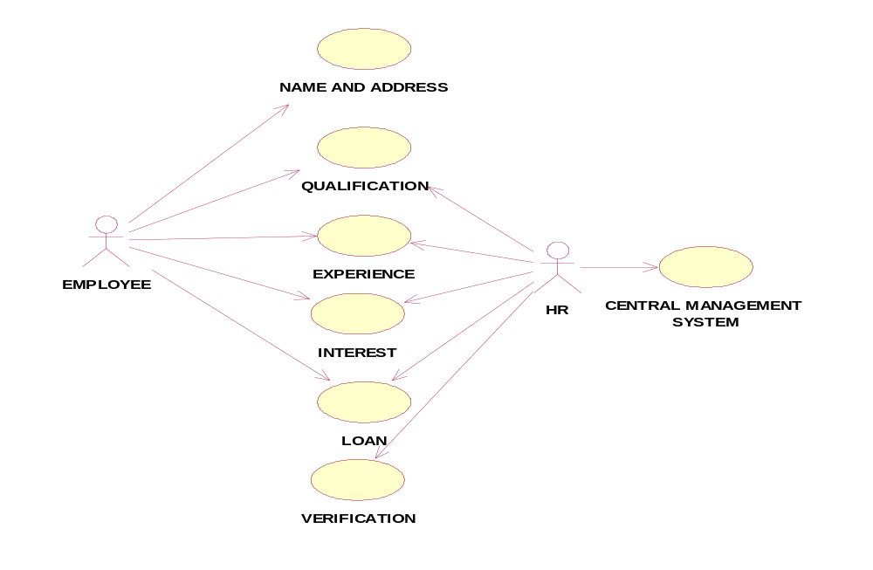
CLASS DIAGRAM:
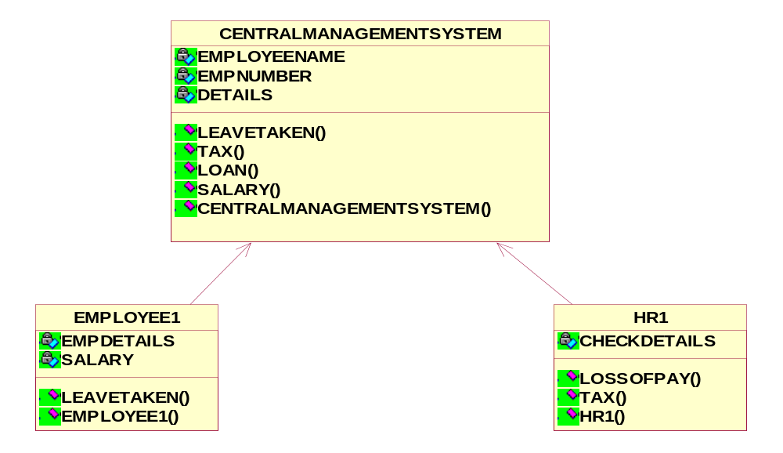

ACTIVITY DIAGRAM:

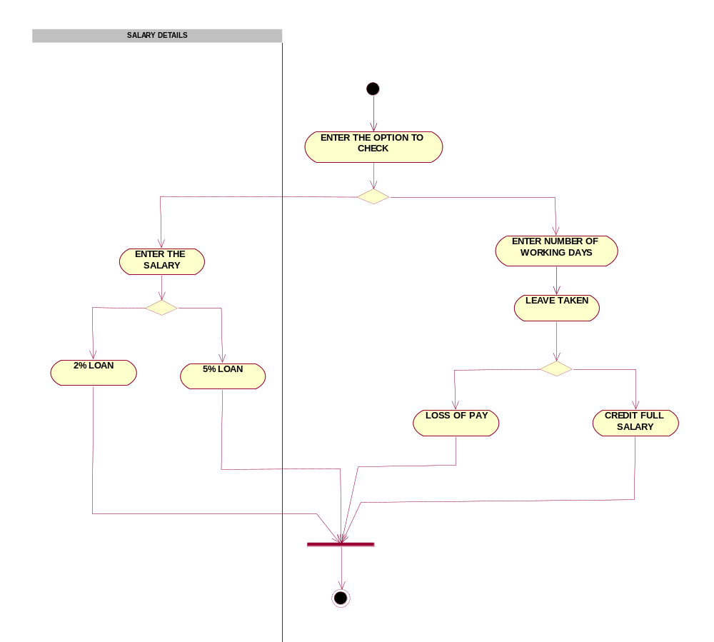

SEQUENCE DIAGRAM:

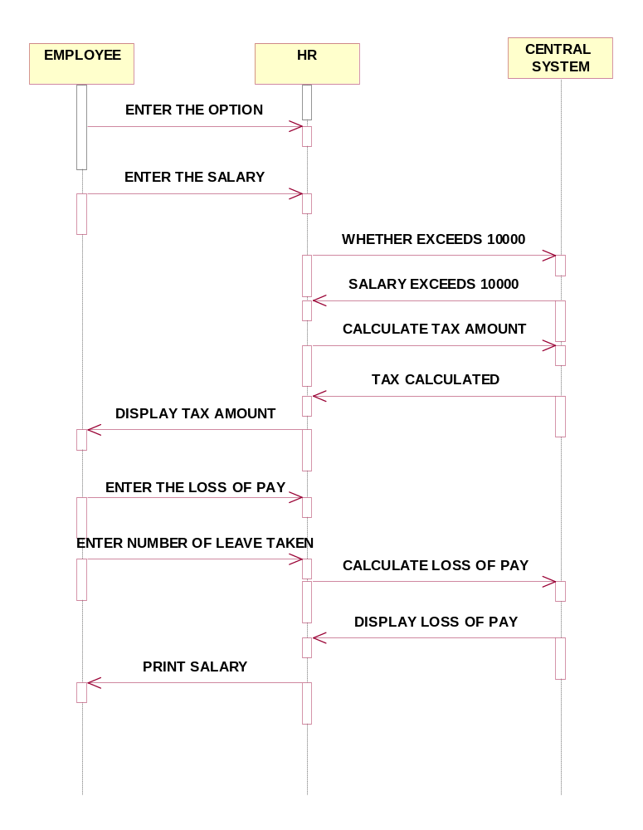

COLLOBORATION DIAGRAM:

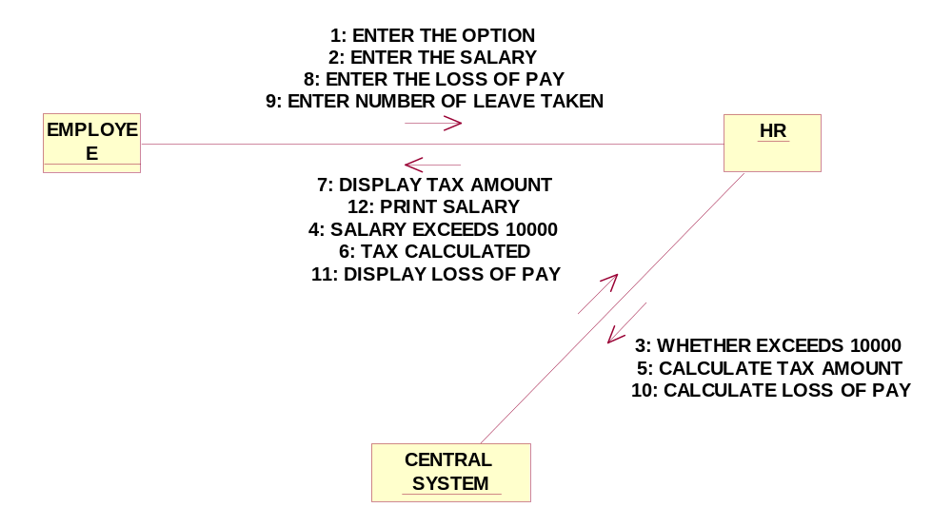

//Source file: Z:\\OOAD LAB\\CENTRALMANAGEMENTSYSTEM.java

public class CENTRALMANAGEMENTSYSTEM
{
private int EMPLOYEENAME;
private int EMPNUMBER;
private int DETAILS;

/**
@roseuid 4D6A16D00179
*/
public CENTRALMANAGEMENTSYSTEM()
{

}

/**
@roseuid 4D50CC50022D
*/

public void LEAVETAKEN()
{

}

/**
@roseuid 4D50CC5900C7
*/
public void TAX()
{

}

/**
@roseuid 4D50CC5C00B7
*/
public void LOAN()
{

}

/**
@roseuid 4D50CC5F0089
*/
public void SALARY()
{

}
}
//Source file: Z:\\OOAD LAB\\EMPLOYEE1.java

public class EMPLOYEE1
{
private int EMPDETAILS;
private int SALARY;
public CENTRALMANAGEMENTSYSTEM theCENTRALMANAGEMENTSYSTEM;

/**
@roseuid 4D6A16D001CE
*/

public EMPLOYEE1()
{

}

/**
@roseuid 4D50CCB20311
*/
public void LEAVETAKEN()
{
}

RESULT:

Thus the diagrams [Use case, class, activity, sequence, collaboration] for the Software personnel management system has been designed, executed and output is verified.

EX.NO:
E-BOOK MANAGEMENT SYSTEM
DATE:

AIM:

To draw the diagrams [usecase, activity, sequence, collaboration, class] for E-book management system

HARDWARE REQUIREMENTS:

- Intel Pentium Processor 3

SOFTWARE REQUIREMENTS:

- Rational rose

PROJECT DESCRIPTION:

This software is designed to manage the books that were read through the internet. This consists of the details of the e-book that were read by the user online. It will be controlled by the central system. This system act as a backup of all details together.

USE CASE DIAGRAM:

This diagram will contain the actors, use cases which are given below
Actors: user, e-book management
Use case: login ,search books, download ,pay for the books, logout

ACTIVITY DIAGRAM:

This diagram will have the activities as Start point ,End point, Decision boxes as given below:

Activities: Search for the e-book site,search for the book,download book
Decision box: check availability

CLASS DIAGRAM:

This diagram consists of the following classes, attributes and their operations.

CLASSES | ATTRIBUTES | OPERATIONS
Internet | Enter id  Login, logout | Surf books()
User | Login ,logout | Surf books()
E-book management | Verify user | Check availability()

SEQUENCE DIAGRAM:

This diagram consists of the objects, messages and return messages.
Object: User ,E-book management ,Internet

COLLABORATION DIAGRAM:

This diagram contains the objects and actors. This will be obtained by the completion of the sequence diagram and pressing the F5 key.

MERITS:

- Provides convenience.
- Easily understandable.
- User friendliness.

DEMERITS:

- Need computer knowledge.
- It is complex for large scale products.

E-BOOK MANAGEMENT SYSTEM

USECASE DIAGRAM:

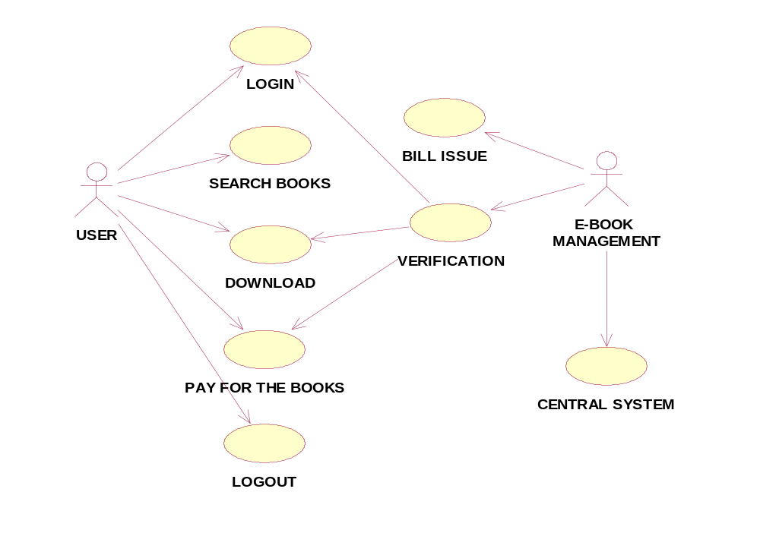
CLASS DIAGRAM:
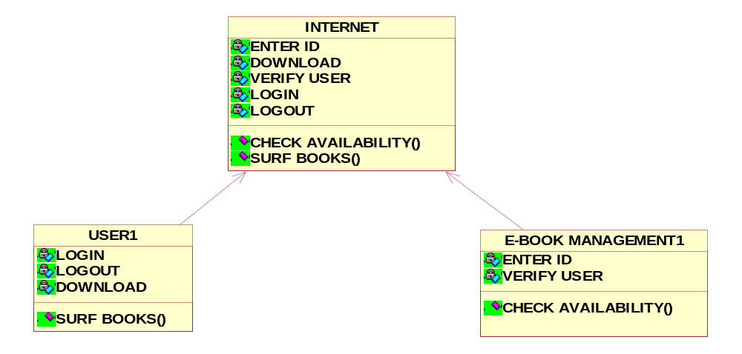

ACTIVITY DIAGRAM:
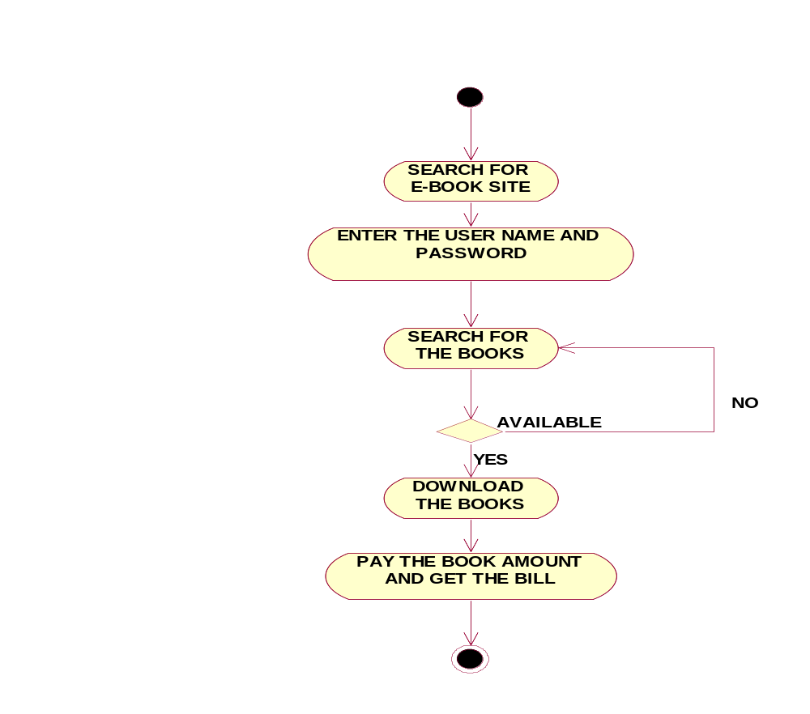
COLLOBORATION DIAGRAM:

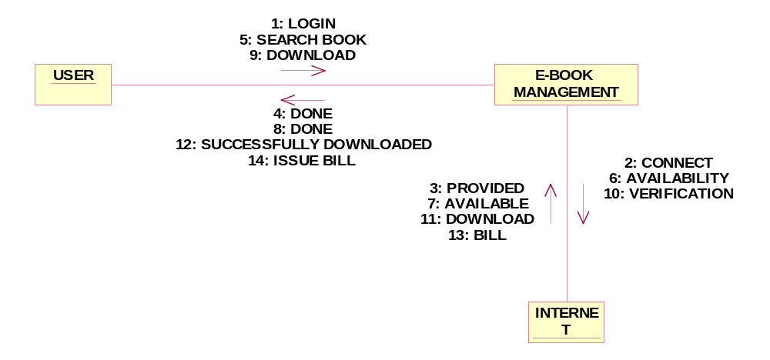

SEQUENCE DIAGRAM:

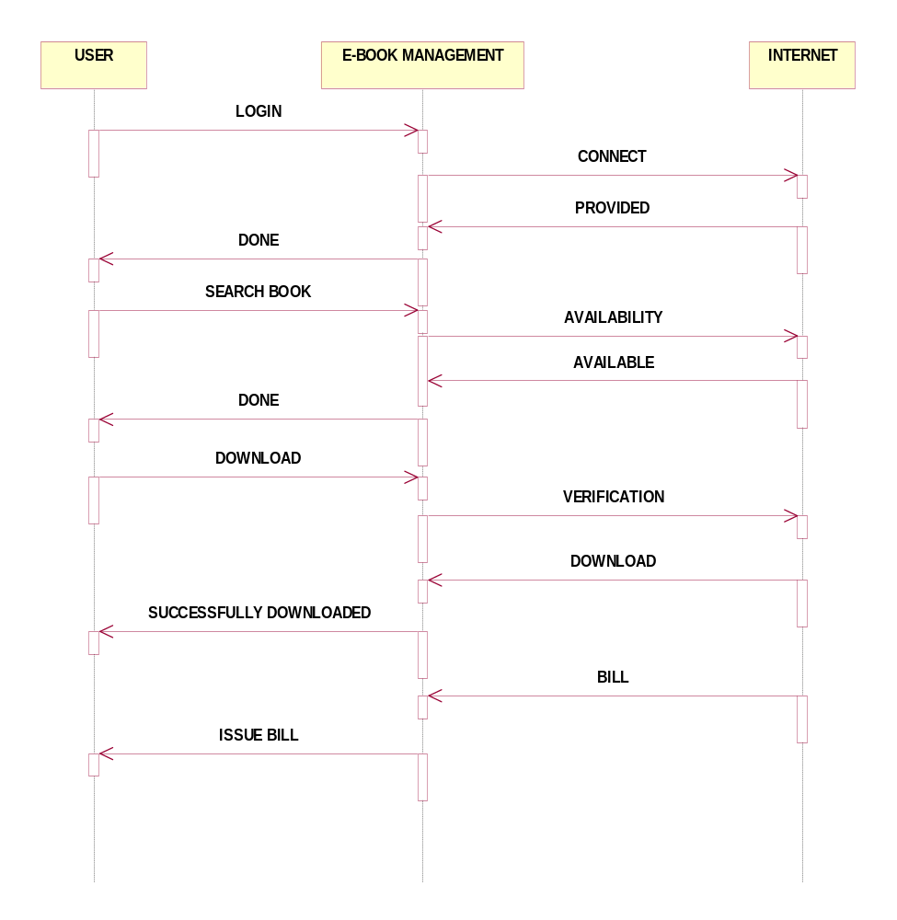

//Source file: Z:\\OOAD\\USER1.java

public class USER1
{
private int LOGIN;
private int LOGOUT;
private int DOWNLOAD;
public INTERNET theINTERNET;

/**
@roseuid 4D6B996D029A
*/
public USER1()
{

}

/**
@roseuid 4D5A0CD902F4
*/
public void SURFBOOKS()
{

}
}

RESULT:

Thus the diagrams [Use case, class, activity, sequence, collaboration] for the E-Book management system has been designed, executed and output is verified.

EX.NO:
RECRUITMENT SYSTEM
DATE:

AIM:
To draw the diagrams [usecase, activity, sequence, collaboration, class] for Recruitment system

HARDWARE REQUIREMENTS:

- Intel Pentium Processor 3

SOFTWARE REQUIREMENTS:

- Rational rose

PROJECT DESCRIPTION:

This system is designed to recruit the particular job to the person in a company .It was controlled by the central management system to manage the details of the particular candidate that one has to be recruited for a company.

USE CASE DIAGRAM:

This diagram will contain the actors, use cases which are given below
Actors: Applicant, HR, Central management system.
Use case: Aptitude, Group discussion, Technical skills, Personal specification, Short list, Result

ACTIVITY DIAGRAM:

This diagram will have the activities as Start point ,End point, Decision boxes as given below:

Activities: Aptitude, Group discussion ,Technical skills,HR
Decision box: Verification of the qualities

CLASS DIAGRAM:

This diagram consists of the following classes, attributes and their operations.

CLASSES | ATTRIBUTES | OPERATIONS
Candidate | Name, qualification | Verify()
HR | Verification ,resume | Select()
Central system | Store, update | Update()

SEQUENCE DIAGRAM:

This diagram consists of the objects, messages and return messages.
Object: Candidate, HR, Central system

COLLABORATION DIAGRAM:

This diagram contains the objects and actors. This will be obtained by the completion of the sequence diagram and pressing the F5 key.

MERITS:

- Provides convenience.
- Easily understandable.
- User friendliness.

DEMERITS:

- Need computer knowledge.
- It is complex for large scale products.

RECRUITMENT SYSTEM

USECASE DIAGRAM:

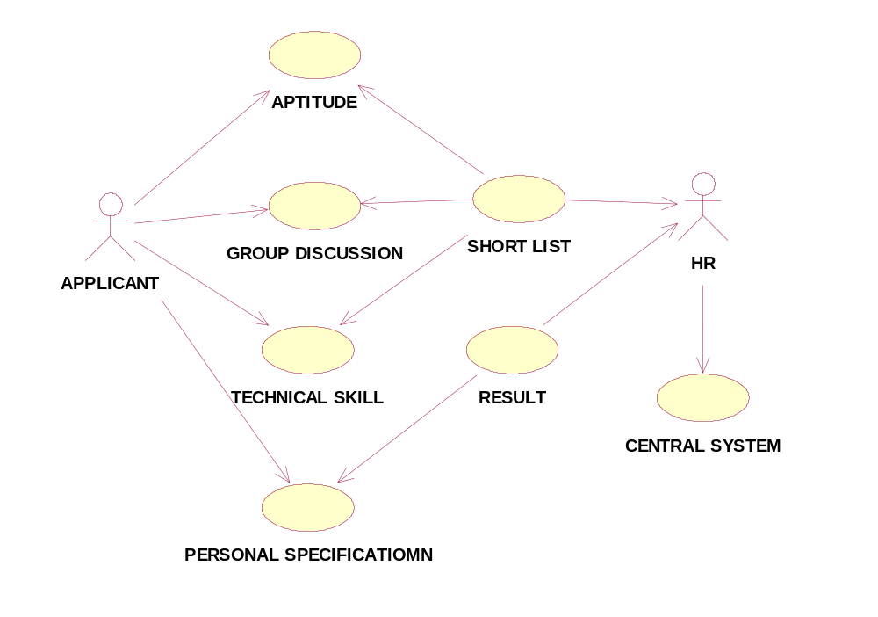
CLASS DIAGRAM:
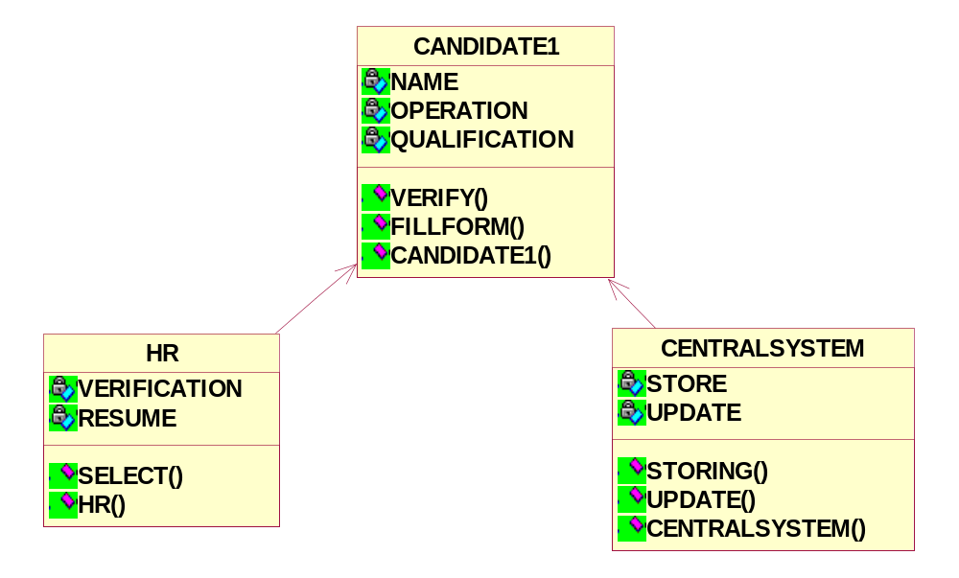

ACTIVITY DIAGRAM:

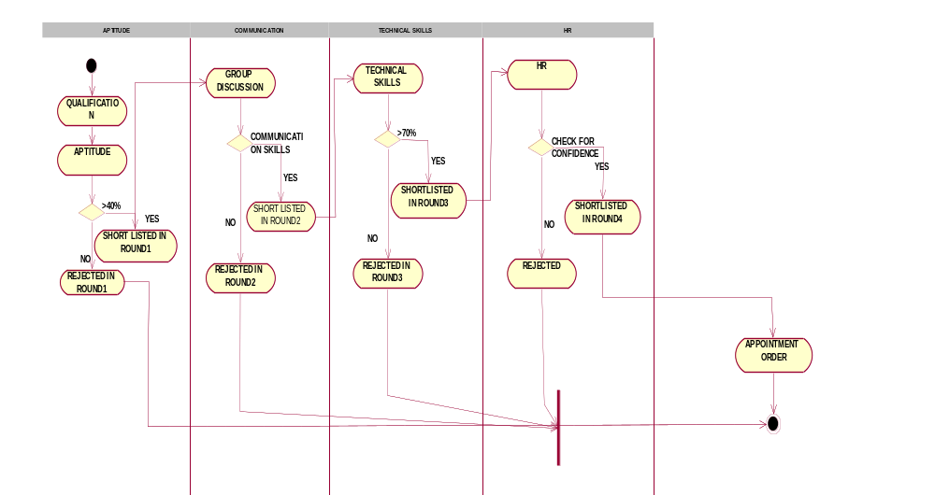

COLLOBORATION DIAGRAM:

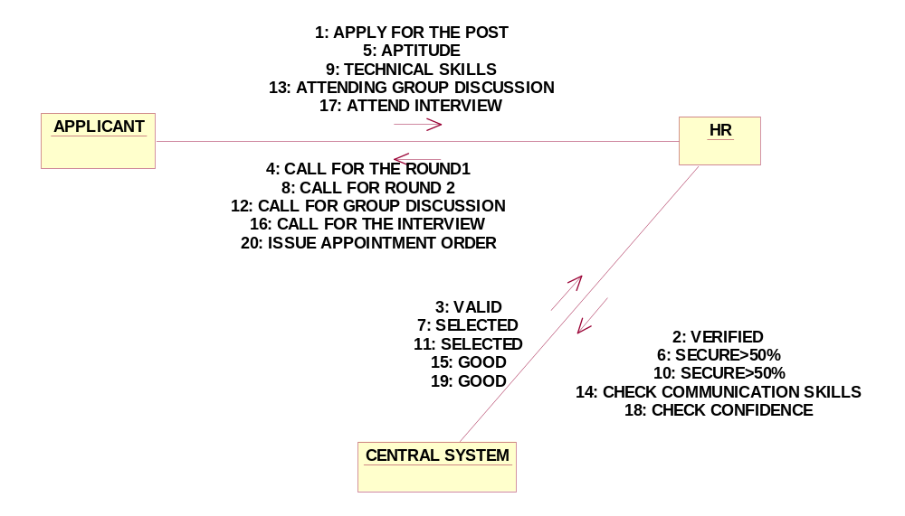

SEQUENCE DIAGRAM:

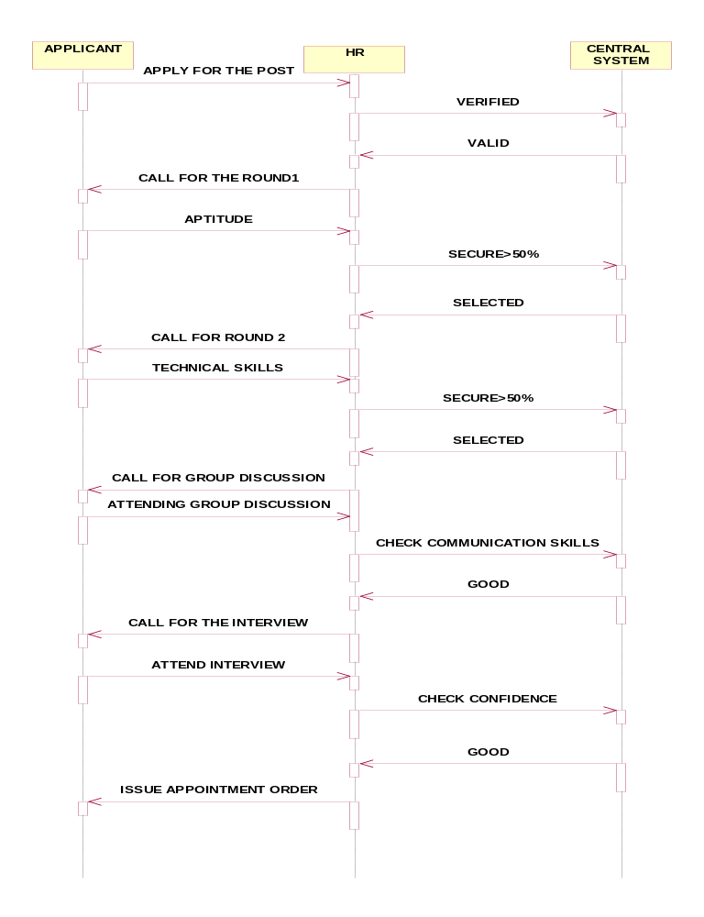

//Source file: Z:\\OOAD\\CANDIDATE1.java

public class CANDIDATE1
{
private int NAME;
private int OPERATION;
private int QUALIFICATION;

/**
@roseuid 4D6BBAF60094
*/
public CANDIDATE1()
{

}

/**
@roseuid 4D6BBA7A00D9
*/
public void VERIFY()
{

}

/**
@roseuid 4D6BBA86028A
*/
public void FILLFORM()
{

}
}
//Source file: Z:\\OOAD\\HR.java

public class HR
{
private int VERIFICATION;
private int RESUME;

public CANDIDATE1 theCANDIDATE1;

/**
@roseuid 4D6BBAF600D3
*/
public HR()
{

}

/**
@roseuid 4D6BBAD20150
*/
public void SELECT()
{

}
}

RESULT:

Thus the diagrams [Use case, class, activity, sequence, collaboration] for the Recruitment system has been designed, executed and output is verified.

EX.NO:
CONFERENCE MANAGEMENT SYSTEM
DATE:

AIM:
To draw the diagrams [usecase, activity, sequence, collaboration, class] for Conference management system

HARDWARE REQUIREMENTS:

- Intel Pentium Processor 3

SOFTWARE REQUIREMENTS:

- Rational rose

PROJECT DESCRIPTION:

This software is designed to manage the details of the process that will be taken place in the conference in a place. It works along with the organizer ,who arranges all these program and central management system, which consists of the all the details of the member who participates in the presentation

USE CASE DIAGRAM:

This diagram will contain the actors, use cases which are given below
Actors: Member, Organizer, Central system
Use case: planning, invite delegates, allocate seats, presenting paper, prize distribution

ACTIVITY DIAGRAM:

This diagram will have the activities as Start point ,End point, Decision boxes as given below:

Activities: Invite delegates, Allocate seats, Presenting paper, Choose the winner
Decision box: Whether it is reserved or not, Whether the presentation is good or not

CLASS DIAGRAM:

This diagram consists of the following classes, attributes and their operations.

CLASSES | ATTRIBUTES | OPERATIONS
Member | Name, id | Presenting paper()
Organiser | Member details | Allocating seats()
Central management system | Member details | Updating()

SEQUENCE DIAGRAM:

This diagram consists of the objects, messages and return messages.
Object: Member, Organiser, Central management system

COLLABORATION DIAGRAM:

This diagram contains the objects and actors. This will be obtained by the completion of the sequence diagram and pressing the F5 key.

MERITS:

- Provides convenience.
- Easily understandable.
- User friendliness.

DEMERITS:

- Need computer knowledge.
- It is complex for large scale products.

CONFERENCE MANAGEMENT SYSTEM

USECASE DIAGRAM:

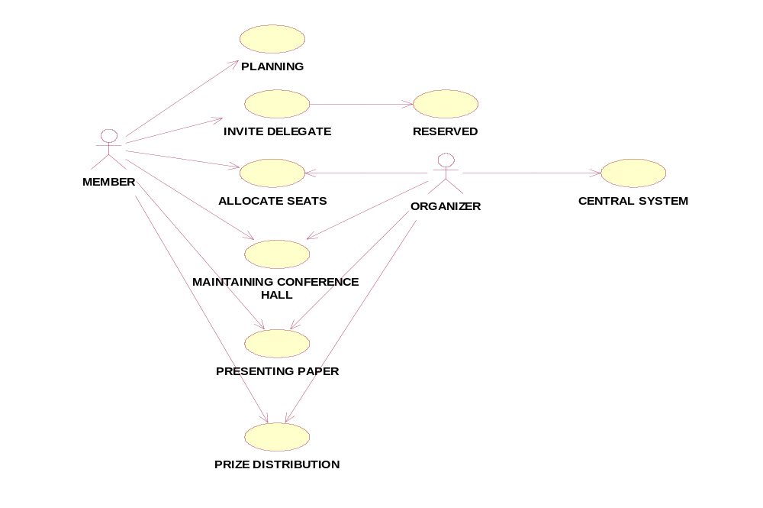
CLASS DIAGRAM:
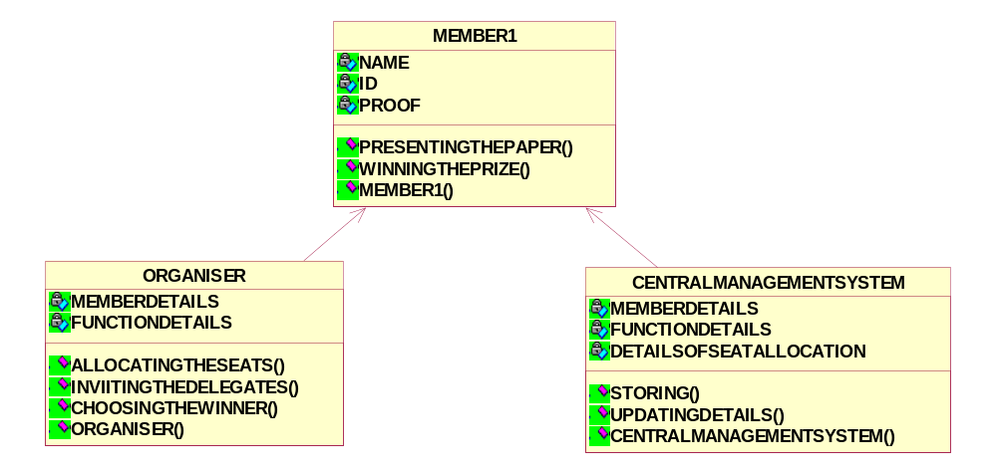

ACTIVITY DIAGRAM:
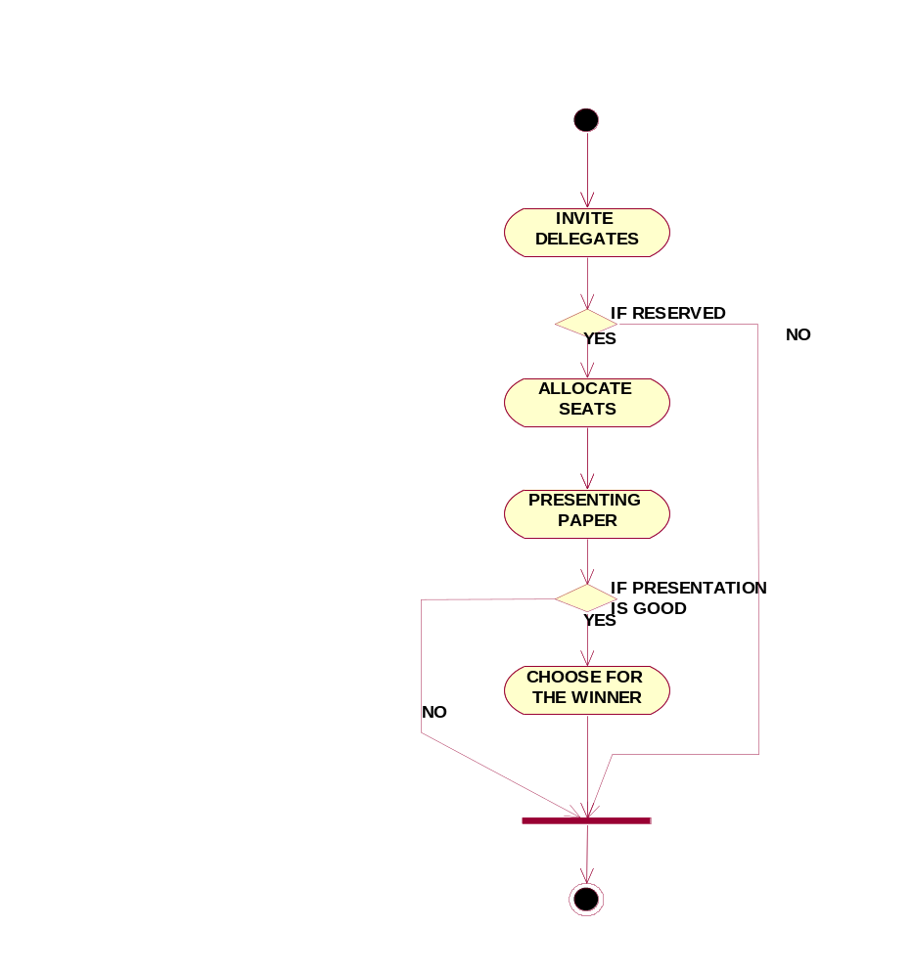
COLLOBORATION DIAGRAM:
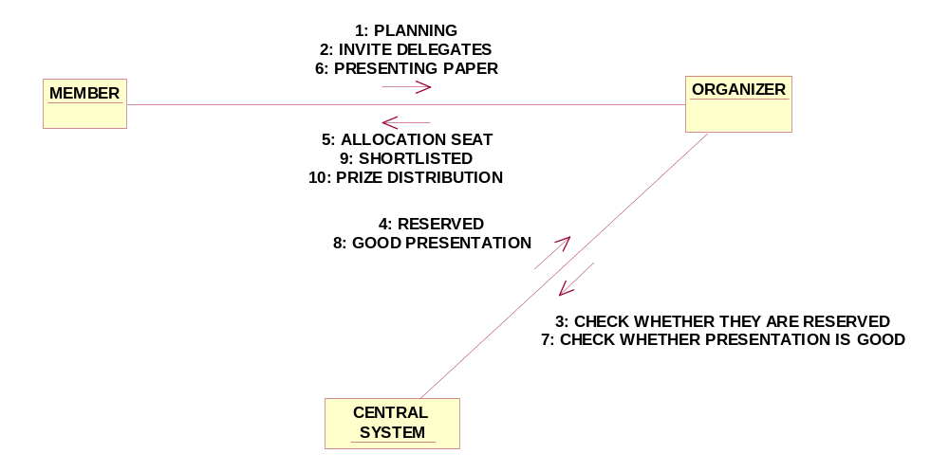

SEQUENCE DIAGRAM:

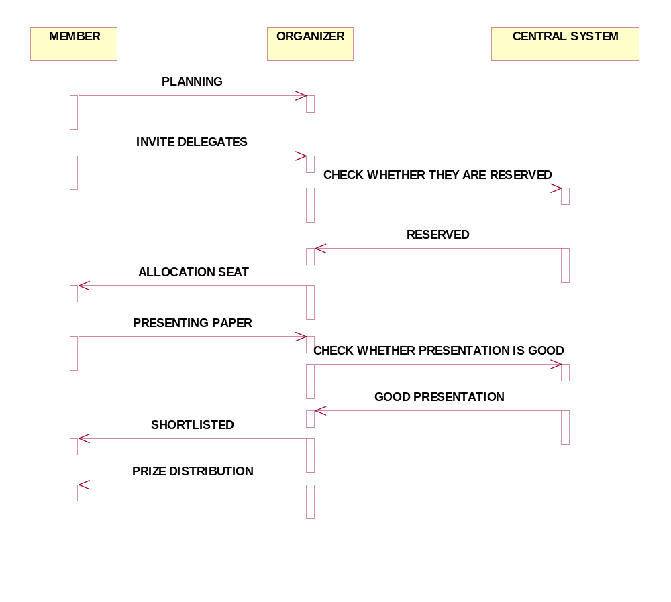

//Source file: Z:\\OOAD\\MEMBER1.java

public class MEMBER1
{
private int NAME;
private int ID;
private int PROOF;

/**
@roseuid 4D6BAC9A0323
*/
public MEMBER1()
{

}

/**
@roseuid 4D6BABC300D8
*/
public void PRESENTINGTHEPAPER()
{

}

/**
@roseuid 4D6BABD20301
*/
public void WINNINGTHEPRIZE()
{

}
}

//Source file: Z:\\OOAD\\ORGANISER.java

public class ORGANISER
{
private int MEMBERDETAILS;
private int FUNCTIONDETAILS;

public MEMBER1 theMEMBER1;

/**
@roseuid 4D6BAC9A0297
*/
public ORGANISER()
{

}

/**
@roseuid 4D6BAC120341
*/
public void ALLOCATINGTHESEATS()
{

}

/**
@roseuid 4D6BAC1C0054
*/
public void INVIITINGTHEDELEGATES()
{

}

/**
@roseuid 4D6BAC28014A
*/
public void CHOOSINGTHEWINNER()
{

}
}

RESULT:

Thus the diagrams [Use case, class, activity, sequence, collaboration] for the Conference management system has been designed, executed and output is verified.

EX.NO:
FOREIGN TRADING SYSTEM
DATE:

AIM:
To draw the diagrams [usecase, activity, sequence, collaboration, class] for Foreign trading system

HARDWARE REQUIREMENTS:

- Intel Pentium Processor 3

SOFTWARE REQUIREMENTS:

- Rational rose

PROJECT DESCRIPTION:

This software is designed to maintain the details about the trading system that exists between the foreign countries. This details are hold by the trading management system.The details to the system are provided by the customer and the supplier

USE CASE DIAGRAM:

This diagram will contain the actors, use cases which are given below
Actors: Customer, Supplier, Custom officer
Use case: Order of product, Quantity, Specify the amount

ACTIVITY DIAGRAM:

This diagram will have the activities as Start point ,End point, Decision boxes as given below:

Activities: Order of the product, Specify amount, Payment, Money transfer
Decision box: Check for availability

CLASS DIAGRAM:

This diagram consists of the following classes, attributes and their operations.

CLASSES | ATTRIBUTES | OPERATIONS
Trading management system | Verify product | Transport()
Customer | Quality | Payment()
Supplier | Product supply | Money transfer()

SEQUENCE DIAGRAM:

This diagram consists of the objects, messages and return messages.
Object: Customer, Supplier, Trading management system

COLLABORATION DIAGRAM:

This diagram contains the objects and actors. This will be obtained by the completion of the sequence diagram and pressing the F5 key.

MERITS:

- Provides convenience.
- Easily understandable.
- User friendliness.

DEMERITS:

- Need computer knowledge.
- It is complex for large scale products.

FOREIGN TRADING SYSTEM

USECASE DIAGRAM:

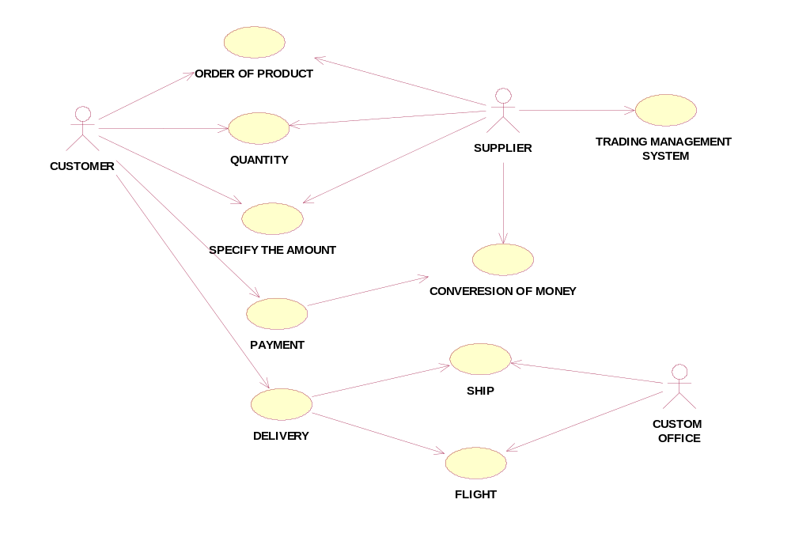CLASS DIAGRAM:
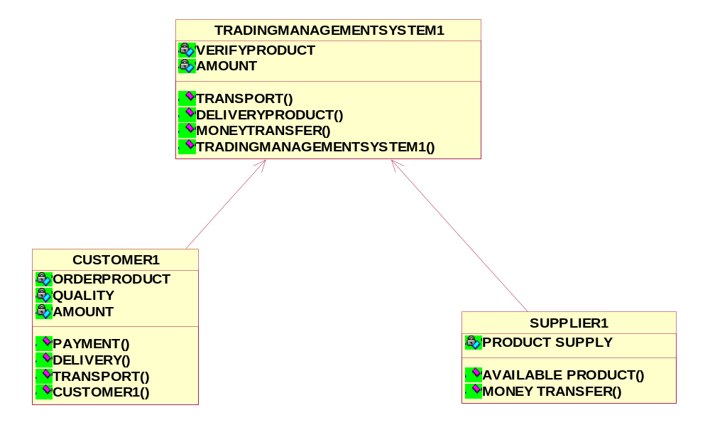

ACTIVITY DIAGRAM:
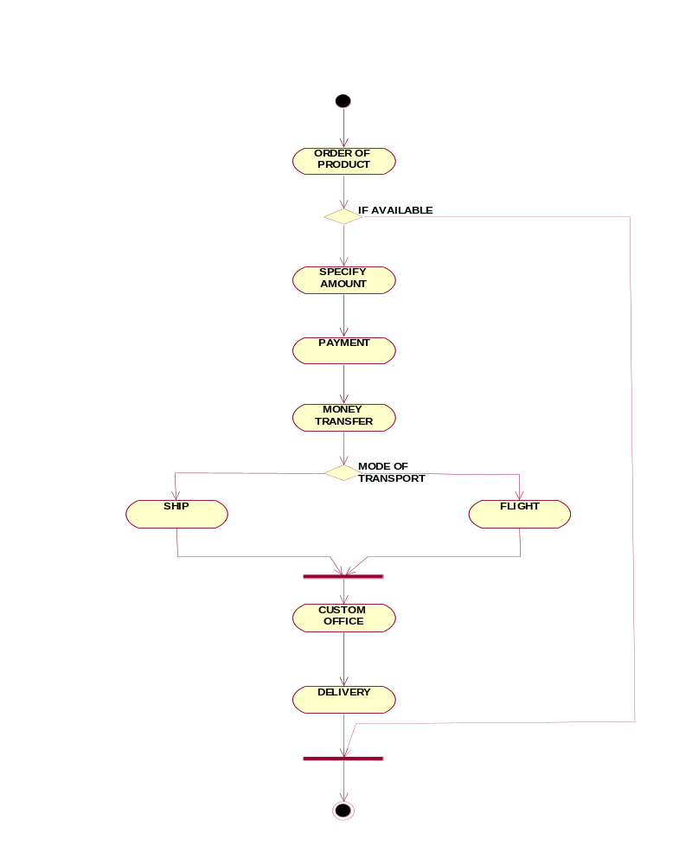

SEQUENCE DIAGRAM:

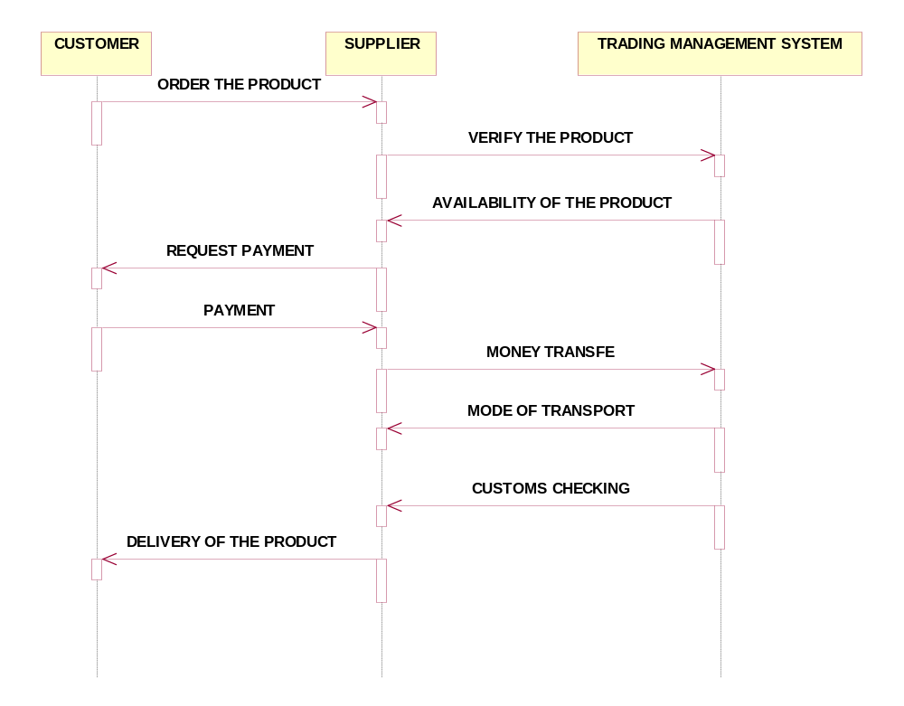

COLLOBORATION DIAGRAM:
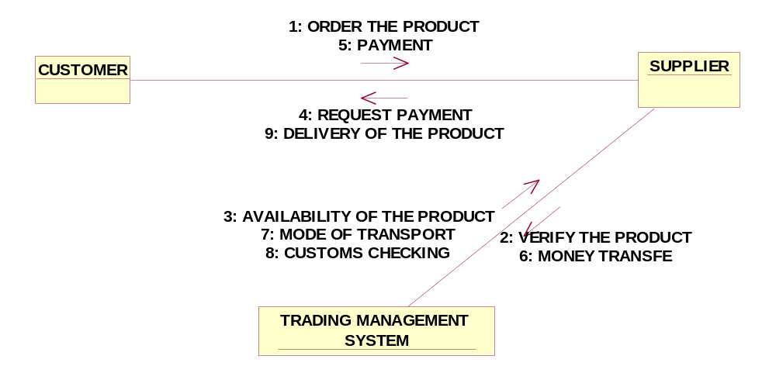

//Source file: Z:\\OOAD\\TRADINGMANAGEMENTSYSTEM1.java
public class TRADINGMANAGEMENTSYSTEM1
{
private int VERIFYPRODUCT;
private int AMOUNT;

/**
@roseuid 4D6BB5B40370
*/
public TRADINGMANAGEMENTSYSTEM1()
{

}

/**
@roseuid 4D6BB5150196
*/
public void TRANSPORT()
{

}

/**
@roseuid 4D6BB51B019C
*/
public void DELIVERYPRODUCT()
{

}
/**
@roseuid 4D6BB523019E
*/
public void MONEYTRANSFER()
{
}}

//Source file: Z\\OOAD\\CUSTOMER1.java
public class CUSTOMER1
{

private int ORDERPRODUCT;
private int QUALITY;
private int AMOUNT;
public TRADINGMANAGEMENTSYSTEM1 theTRADINGMANAGEMENTSYSTEM1;

/**
@roseuid 4D6BB5B40331
*/
public CUSTOMER1()
{

}

/**
@roseuid 4D6BB57C0040
*/
public void PAYMENT()
{

}

/**
@roseuid 4D6BB58001C0
*/
public void DELIVERY()
{
}
/**
@roseuid 4D6BB5840275
*/
public void TRANSPORT()
{
}}

RESULT:

Thus the diagrams [Use case, class, activity, sequence, collaboration] for the Trading management system has been designed, executed and output is verified.

EX.NO:
BPO MANAGEMENT SYSTEM
DATE:

AIM:
To draw the diagrams [usecase, activity, sequence, collaboration, class] for BPO management system

HARDWARE REQUIREMENTS:

- Intel Pentium Processor 3

SOFTWARE REQUIREMENTS:

- Rational rose

PROJECT DESCRIPTION:

This software is designed to know about the process that were taking place in the BPO office. This system holds the details of the customer who and all approaches to it. It is managed by the central system..

USE CASE DIAGRAM:

This diagram will contain the actors, use cases which are given below
Actors: Customer, Server, Central system
Usecase: Product, Voice, NonVoice,Indianoffice,Employee,Feedback.

ACTIVITY DIAGRAM:

This diagram will have the activities as Start point ,End point, Decision boxes as given below:

Activities: Purchase product, oncall, onchat
Decision box: Option to check

CLASS DIAGRAM:

This diagram consists of the following classes, attributes and their operations.

CLASSES | ATTRIBUTES | OPERATIONS
Central system | Store, update | Storing(),updating()
Dealer | Employee name | Delivery()
Customer | details | Feedback()

SEQUENCE DIAGRAM:

This diagram consists of the objects, messages and return messages.
Object :Customer, Dealer, Central system

COLLABORATION DIAGRAM:

This diagram contains the objects and actors. This will be obtained by the completion of the sequence diagram and pressing the F5 key.

MERITS:

- Provides convenience.
- Easily understandable.
- User friendliness.

DEMERITS:

- Need computer knowledge.
- It is complex for large scale products.

BPO MANAGEMENT SYSTEM

USECASE DIAGRAM:
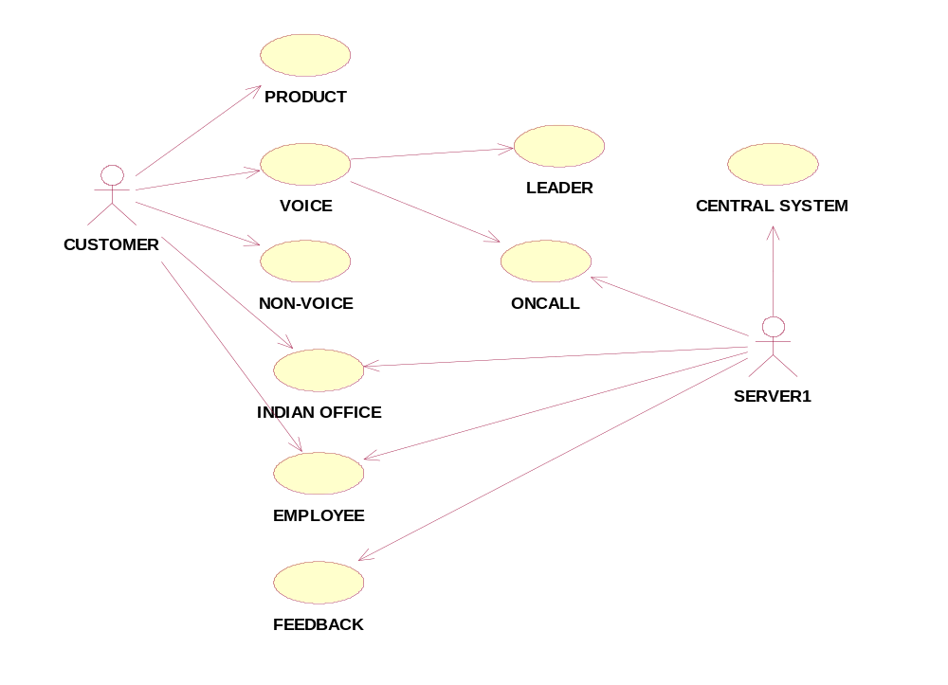
CLASS DIAGRAM
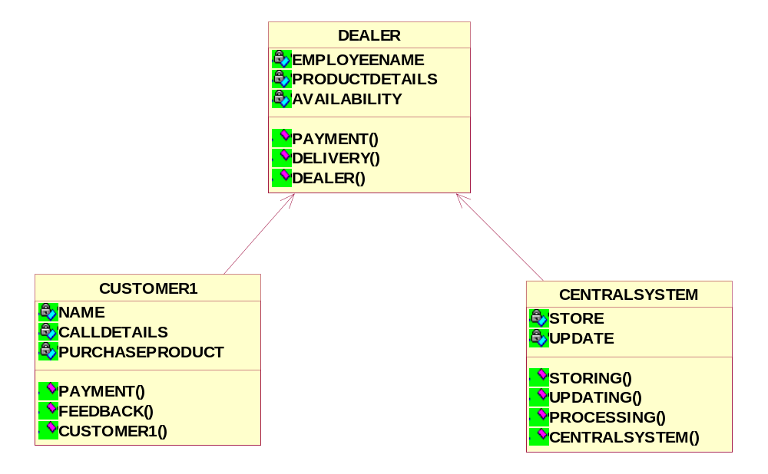

ACTIVITY DIAGRAM:
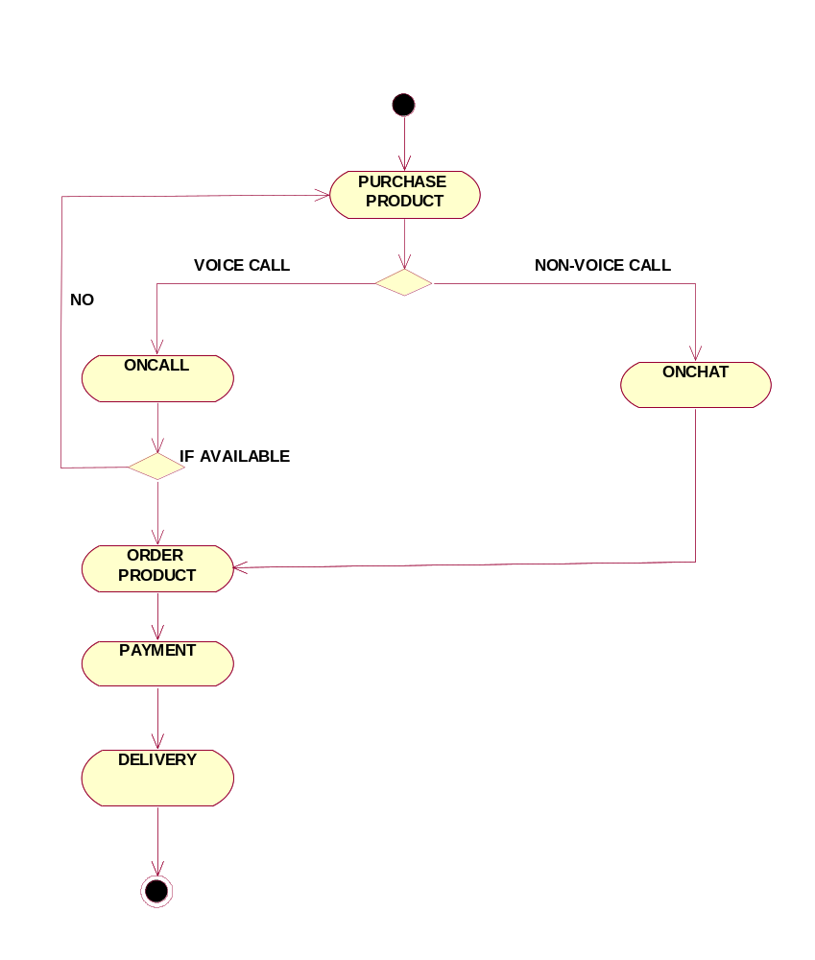

SEQUENCE DIAGRAM:

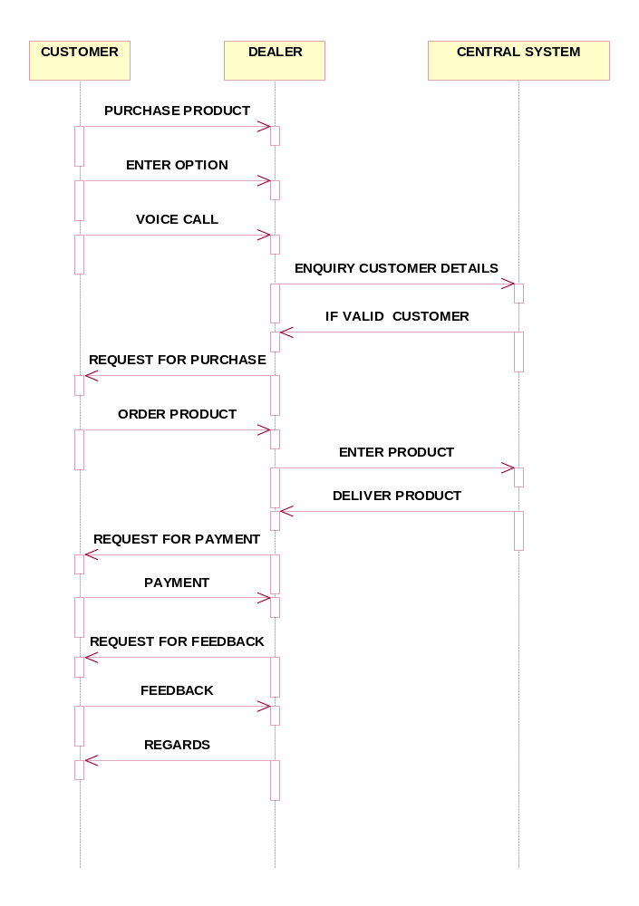

COLLABORATION DIAGRAM:

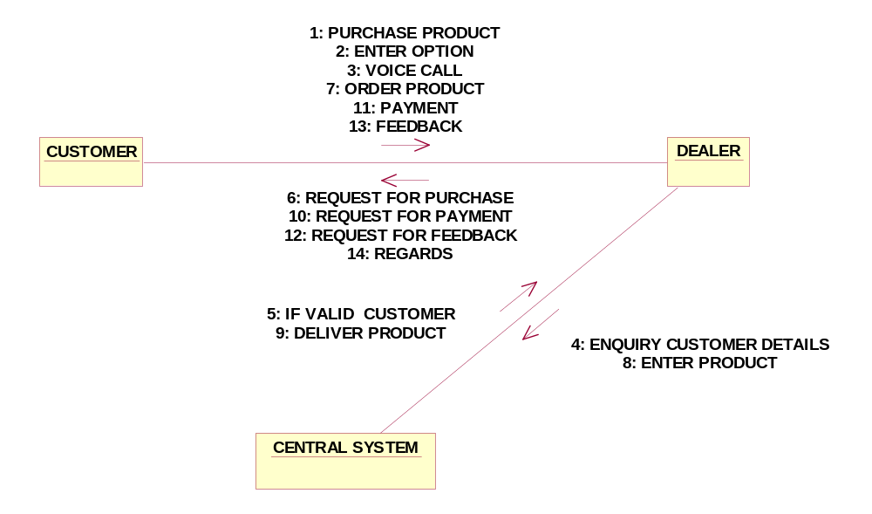

//Source file: Z:\\OOAD\\CENTRALSYSTEM.java

public class CENTRALSYSTEM
{
private int STORE;
private int UPDATE;
public DEALER theDEALER;

/**
@roseuid 4D75B7BF025A
*/
public CENTRALSYSTEM()
{

}

/**
@roseuid 4D75B71B018E
*/
public void STORING()
{

}

/**
@roseuid 4D75B723031C
*/
public void UPDATING()
{

}

/**
@roseuid 4D75B7300163
*/
public void PROCESSING()
{

}
}

RESULT:

Thus the diagrams [Use case, class, activity, sequence, collaboration] for the BPO management system has been designed, executed and output is verified.

